MedVista

Muhammad Atif Yar (212056)

Areeba Zahid (211292)

Ahtasham Sajawal (211356)



Spring - 2024
Supervised By
Ch. Anwar Ul Hassan

Department of Creative Technologies
Faculty of Computing & AI
Air University, Islamabad

 | PROJECT REPORT | 

Version |  | V X.0 |  |  | NUMBER OF MEMBERS | 3
TITLE | MedVista
SUPERVISOR NAME |  |  | Ch. Anwar Ul Hassan

MEMBER NAME | REG. NO. | EMAIL ADDRESS
Muhammad Atif Yar | 212056 | 212056@students.au.edu.pk
Areeba Zahid | 211292 | 211292@students.au.edu.pk
Ahtasham Sajawal | 211356 | 211356@students.au.edu.pk

MEMBERS’ SIGNATURES
Supervisor’s Signature

APPROVAL CERTIFICATE

This project, entitled as “MedVista” has been approved for the award of
Bachelors of Science in Software Engineering

Committee Signatures:

Supervisor: __________________________

(Mr. Anwar Ul Hassan)

Program Lead: __________________________

(Dr. Imran Ihsan)

Head of Department: __________________________

(Dr. Imran Ihsan)

DECLARATION

I/We, hereby, declare that “No portion of the work referred to, in this project has been submitted in support of an application for another degree or qualification of this or any other university/institute or other institution of learning”. It is further declared that this undergraduate project, neither as a whole nor as a part thereof has been copied out from any sources, wherever references have been provided.

MEMBERS’ SIGNATURES

ACKNOWLEDGEMENTS

It is usual to thank those individuals who have provided particularly useful assistance, technical or otherwise, during your project. Your supervisor will obviously be pleased to be acknowledged as he or she will have invested quite a lot of time overseeing your progress.

Executive Summary

This should be no more than one page in length (200 words approx.). The summary should allow the reader who is unfamiliar with the work to gain a swift and accurate impression of what the project is about, how it arose and what has been achieved.

It is recommended, you write this section when the report is finished.

Table of Contents

Contents
ACKNOWLEDGEMENTS v
Executive Summary vii
Chapter 1 1
Introduction 1
1.1. Project Introduction 1
1.2. Existing Examples / Solutions 1
1.3. Business Scope 1
1.3.1 Transaction Fee 2
1.3.2 Premium Features 2
1.3.3 Sponsored Listings 2
1.3.4 Data Insights and Analytics 2
1.3.5 Affiliate Partnerships 2
1.3.6 Advertising Revenue 3
1.4 Useful Tools and Technologies 3
1.5. Project Work Break Down 4
1.6. Project Feasibility 5
1.6.1 Technical Feasibility 6
1.6.2 Operational Feasibility 6
1.6.3 Economic Feasibility 6
1.6.4 Schedule Feasibility 6
1.6.5 Specification Feasibility 6
1.6.6 Information Feasibility 7
1.6.7 Motivational Feasibility 7
1.6.8 Legal & Ethical Feasibility 7
1.7 Risk List 8
1.7.1. Technical Risks 8
1.7.2. Operational Risks 8
1.7.3. Economic Risks 8
1.7.4. Schedule Risks 9
1.7.5. Specification Risks 9
1.7.6. Information Risks 9
1.7.7. Motivational Risks 9
1.7.8. Legal & Ethical Risks 10
1.8 Project Timeline 10
Chapter 2 11
Requirement Specification and Analysis 11
Requirement Specification 11
2.1. Functional Requirements 11
2.1.1 User Authentication and Management 11
2.1.2 User Profile Management 12
2.1.3 Catalog Management 12
2.1.4 Prescription Management 12
2.1.5 Cart Management 13
2.1.6 Order Fulfillment and Management 13
2.1.8 Customer Feedback 14
2.1.9 Notifications 14
2.2.0 Customer Support 15
2.2. Non-Functional Requirements 16
Security 16
Accuracy and Reliability 16
Performance 16
Scalability 16
Accessibility 17
2.3 System Use Case Modeling 18
2.4 Fully-dressed Use Cases 19
2.5 Domain Model 51
Chapter 3 52
System Design 52
3.1. Class Diagram 52
3.2. Sequence Diagram 52
3.3. System Sequence Diagram 55
3.4. Activity Diagram 72
3.5. State Transition Diagram 93
3.6. Database Schema 94
3.7. User Interface Design 99
3.8. Software COTS 99
Chapter 4 101
Software Development 101
4.1. Coding Standards 101
4.2. Development Environment 101
4.3. Software Description 102

List of Figures

The report contains only a single figure whose number and name is mentioned below.

Figure 1.1 Work Breakdown

Figure 1.2: Sample Gant Chart

Figure 2.1: Use Case Diagram

Figure 2.2: Domain Model

Table 2.1: Functional Requirements

Table 2.2: Non-Functional Requirements

Table 2.3: Use Case 1
Table 2.4: Use Case 2
Table 2.5: Use Case 3
Table 2.6: Use Case 4
Table 2.7: Use Case 5
Table 2.8: Use Case 6
Table 2.9: Use Case 7
Table 2.10: Use Case 8
Table 2.11: Use Case 9
Table 2.12: Use Case 10
Table 2.13: Use Case 11
Table 2.14: Use Case 12
Table 2.15: Use Case 13
Table 2.16: Use Case 14
Table 2.17: Use Case 15
Table 2.18: Use Case 16
Table 2.19: Use Case 17
Table 2.20: Use Case 18
Table 2.21: Use Case 19
Table 2.22: Use Case 20
Table 2.23: Use Case 21
Figure 3.1: Class Diagram
Figure 3.2: Sequence Diagram
Figure 3.3.1: System Sequence Diagram 1
Figure 3.3.2: System Sequence Diagram 2
Figure 3.3.3: System Sequence Diagram 3
Figure 3.3.4: System Sequence Diagram 4
Figure 3.3.5: System Sequence Diagram 5
Figure 3.3.6: System Sequence Diagram 6
Figure 3.3.7: System Sequence Diagram 7
Figure 3.3.8: System Sequence Diagram 8
Figure 3.3.9: System Sequence Diagram 9
Figure 3.3.10: System Sequence Diagram 10
Figure 3.3.11: System Sequence Diagram 11
Figure 3.3.12: System Sequence Diagram 12
Figure 3.3.13: System Sequence Diagram 13
Figure 3.3.14: System Sequence Diagram 14
Figure 3.3.15: System Sequence Diagram 15
Figure 3.3.16: System Sequence Diagram 16
Figure 3.3.17: System Sequence Diagram 17
Figure 3.3.18: System Sequence Diagram 18
Figure 3.3.19: System Sequence Diagram 19
Figure 3.3.20: System Sequence Diagram 20
Figure 3.3.21: System Sequence Diagram 21
Figure 3.4.1: Activity Diagram 1
Figure 3.4.2: Activity Diagram 2
Figure 3.4.3: Activity Diagram 3
Figure 3.4.4: Activity Diagram 4
Figure 3.4.5: Activity Diagram 5
Figure 3.4.6: Activity Diagram 6
Figure 3.4.7: Activity Diagram 7
Figure 3.4.8: Activity Diagram 8
Figure 3.4.9: Activity Diagram 9
Figure 3.4.10: Activity Diagram 10
Figure 3.4.11: Activity Diagram 11
Figure 3.4.12: Activity Diagram 12
Figure 3.4.13: Activity Diagram 13
Figure 3.4.14: Activity Diagram 14
Figure 3.4.15: Activity Diagram 15
Figure 3.4.16: Activity Diagram 16
Figure 3.4.17: Activity Diagram 17
Figure 3.4.18: Activity Diagram 18
Figure 3.4.19: Activity Diagram 19
Figure 3.4.20: Activity Diagram 20
Figure 3.4.21: Activity Diagram 21
Figure 3.5: State Transition Diagram
Figure 3.6: Database Schema

This page is kept blank

Chapter 1

Introduction

Project Introduction

MedVista is an innovative mobile application designed to revolutionize medication accessibility and management in the healthcare industry. In today's world, accessing affordable medication and managing unused or expired medications are significant challenges faced by individuals and healthcare organizations alike. MedVista addresses these challenges by offering a comprehensive platform that empowers users to find affordable alternatives for prescribed medications, sell or donate unused medications, and make informed healthcare decisions.

Existing Examples / Solutions

Pharmapedia Pakistan is an existing example related to our project. It is a mobile app providing comprehensive information about medicines, including uses, dosage, side effects, and alternatives. It serves as a valuable resource for patients and healthcare professionals but lacks functionalities for donating or selling unused medicines. In contrast, MedVista allows users to upload details of unused medicines for sale or donation, addressing medication affordability and accessibility. MedVista also aims to reduce wastage by encouraging medication donations, promoting sustainability and social responsibility in healthcare.

1.3. Business Scope

MedVista's business model is designed to generate revenue while fulfilling its mission of improving medication accessibility and reducing wastage. The following strategies outline how the app can monetize its services:

1.3.1 Transaction Fee

MedVista can earn revenue through transaction fees charged on each sale or donation facilitated through the platform. A small percentage of the transaction amount can be charged as a commission.

1.3.2 Premium Features

The app can offer premium features or subscription plans to users who wish to access additional functionalities, such as priority listing for selling medicines, advanced search filters, or personalized health recommendations. Users can pay a monthly or annual subscription fee for access to these features.

1.3.3 Sponsored Listings

Pharmacies or healthcare organizations can pay for sponsored listings, where their medicines are highlighted or promoted within the app's search results. This can provide additional visibility for their products and generate revenue for MedVista.

1.3.4 Data Insights and Analytics

MedVista can aggregate anonymized user data and provide insights and analytics to pharmaceutical companies, healthcare providers, and researchers. These insights can be valuable for understanding medication usage patterns, market trends, and patient preferences, providing a revenue stream through data licensing or partnerships.

1.3.5 Affiliate Partnerships

MedVista can establish affiliate partnerships with pharmacies or online retailers, earning a commission on sales generated through referral links from the app. This can incentivize users to purchase medications through the platform, benefiting both the users and MedVista.

1.3.6 Advertising Revenue

Medvista can display targeted advertisements from healthcare-related businesses, such as pharmaceutical companies, clinics, or health insurance providers. Advertisers can pay for ad placements within the app, generating revenue based on impressions or clicks.

Useful Tools and Technologies

For the development of MedVista, we have chosen a robust set of tools and technologies to ensure a seamless and efficient user experience across various platforms. Here are the key technologies we are utilizing:
React Native
React Native is an excellent choice for building mobile applications that run on both iOS and Android platforms using a single codebase. This not only reduces development time and costs but also ensures consistency in the user experience across different devices. Its extensive library support and active community make it a reliable framework for mobile app development.
MongoDB
To store user data, prescriptions, medicine information, and transactional data, we are utilizing MongoDB, a NoSQL database known for its flexibility and scalability. MongoDB's document-oriented structure allows for efficient storage and retrieval of data, making it an ideal choice for our application's needs. Its ability to handle large volumes of data and perform real-time updates ensures that users always have access to the most current information.
APIs for Medicine Data
To fetch comprehensive medicine data, including alternatives, prices, and availability, we are utilizing APIs and datasets.
Figma
For UI design and mockups, we are using Figma. This collaborative design tool allows us to create, test, and refine our app's user interface efficiently. Figma's real-time collaboration features enable our team to work together seamlessly, ensuring a cohesive and user-friendly design.
VN and CapCut
For video editing, we are utilizing VN and CapCut. These tools provide powerful video editing capabilities, allowing us to create engaging promotional and instructional videos for our app. Their user-friendly interfaces and extensive features make video editing both efficient and effective.
Adobe Illustrator and Canva
For graphic design work, we are using Adobe Illustrator and Canva. Illustrator is a professional-grade tool for creating detailed vector graphics, while Canva provides an accessible platform for creating various graphic designs quickly. Together, these tools enable us to produce high-quality graphics for our app's branding and marketing materials.
By combining these technologies, MedVista is poised to deliver a powerful, user-friendly application that addresses medication affordability and accessibility, while promoting sustainability in healthcare practices.

Project Work Break Down

Following is the work breakdown:
Frontend Development: Muhammad Atif Yar
Backend Development: Ahtasham Sajawal
Documentation: Areeba Zahid
Database Design: Ahtasham Sajawal & Areeba Zahid
UI/UX Design: Muhammad Atif Yar
Testing and Quality Assurance: Muhammad Atif Yar & Areeba Zahid
Graphics and video editing: Muhammad Atif Yar

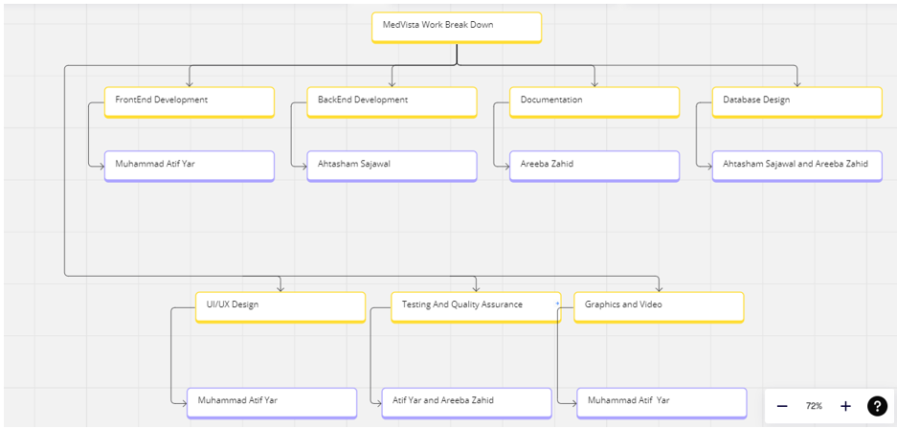
Figure 1.1: Work Breakdown

Project Feasibility

The feasibility of MedVista application and its medicine donation initiative is grounded in several key factors:

Technical Feasibility

We possess technical expertise and resources to develop and maintain a robust app infrastructure. It includes user authentication, image recognition algorithms, secure payment gateways and donation facilitation features. Our team is well-equipped to integrate these functionalities.

Operational Feasibility

We have identified and addressed potential operational challenges such as data security, regulatory compliance and logistics for medicine donation. By leveraging partnerships with healthcare organizations and NGOs, we aim to ensure smooth project execution and maximize our impact on healthcare accessibility.

Economic Feasibility

The app hinges on the examination of costs and potential returns on investment. Integral factors include the development, operational and revenue expenses. Initial investments are for frontend and backend development, integration of image recognition algorithms and database setup. Continual expenses for updates, maintenance must be considered.

Schedule Feasibility

The schedule feasibility revolves around the capability to meet the timelines and fulfill the stakeholders’ expectations for timely delivery. We have planned out what needs to happen and when, from gathering the ideas to testing the application and finally launching it. Backup plans are devised in case of any unforeseen challenge.

Specification Feasibility

Specification feasibility for MedVista involves ensuring that the project requirements are clear, well-defined, and achievable within the project's constraints. Clear and well-defined requirements facilitate effective development by providing a roadmap for the development team and enabling accurate implementation of desired features. Additionally, having clear requirements supports efficient scope management, helping to prevent scope creep and ensuring that the project stays on track to deliver its objectives of improving medication accessibility and reducing waste.

Information Feasibility

It focuses on making sure that the application has access to right data and information. It includes gathering accurate details about the medicines from reliable resources, ensuring up-to-date pricing information and verifying their availability.

Motivational Feasibility

Ensuring that our application is motivational involves inspiring both the team and users. We make sure to communicate the benefits our application can have on the individual’s lives. We motivate our team by showcasing the difference our application can make.

Legal & Ethical Feasibility

Our app compiles with applicable rules, regulations and standards. We prioritize the ethical considerations like protecting user confidentiality and promoting transparency in pricing. We also conduct thorough legal research in order to obtain necessary license and permissions along with ensuring secure transactions.

Risk List

Following factors are in risk list.

1.7.1. Technical Risks

Technical risks involve challenges related to the integration of external systems and potential security vulnerabilities. Integration challenges may arise when connecting Medvista with existing healthcare databases or third-party services, potentially delaying the project's progress. Additionally, ensuring robust cybersecurity measures is crucial to protect user data from breaches or unauthorized access.

1.7.2. Operational Risks

Operational risks include the possibility of slower-than-anticipated user adoption and limited availability of donated medicines. User adoption may be affected by factors such as user interface design, marketing efforts, or competition from existing healthcare apps. Limited availability of donated medicines could impact MedVista's ability to fulfill its mission of redistributing unused medications.

1.7.3. Economic Risks

Economic risks encompass fluctuations in healthcare regulations and policies, as well as competition from existing medication discount programs. Changes in regulations or policies may affect the app's revenue streams or market viability. Competition from established discount programs could pose challenges in attracting users and generating revenue.

1.7.4. Schedule Risks

Schedule risks involve delays in development or testing phases and unexpected changes in project scope. Delays may occur due to technical issues, resource constraints, or unforeseen obstacles. Changes in project scope, such as new feature requests or alterations to existing requirements, can disrupt project timelines and increase development time and costs.

1.7.5. Specification Risks

Specification risks relate to misinterpretation of user requirements and scope creep leading to feature bloat. Misunderstandings or incomplete requirements documentation may result in the delivery of a product that does not meet user expectations. Scope creep, where additional features are added beyond the project's original scope, can lead to increased development complexity and delays.

1.7.6. Information Risks

Information risks involve data breaches or loss of sensitive information and inaccurate or outdated medication information. Protecting user data from breaches or loss is essential to maintain trust and comply with privacy regulations. Ensuring the accuracy and currency of medication information is crucial for providing reliable service to users.

1.7.7. Motivational Risks

Motivational risks include team member burnout or disengagement and lack of stakeholder support or interest. Burnout or disengagement can result from prolonged periods of intense work or unresolved conflicts within the team. Lack of support from stakeholders, such as investors or management, may lead to decreased morale and productivity.

1.7.8. Legal & Ethical Risks

Legal and ethical risks involve non-compliance with healthcare regulations and intellectual property infringement. Failure to comply with regulations governing healthcare data privacy and security could result in legal consequences and damage to MedVista's reputation. Additionally, infringing on intellectual property rights could lead to legal disputes and financial penalties.

Project Timeline

Figure 1.2: Sample Gant Chart

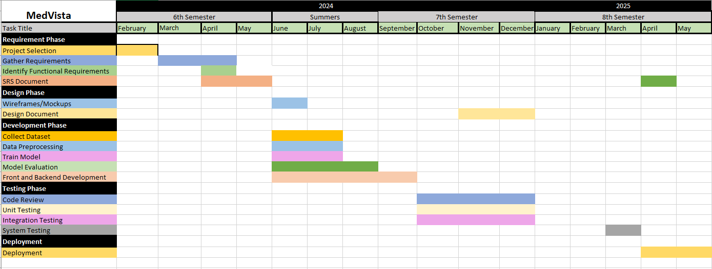

Chapter 2

Requirement Specification and Analysis

Requirement Specification

2.1. Functional Requirements
Following are the functional requirements:

2.1.1 User Authentication and Management

To access the features of the medical app, users must first register by providing their email or phone number and selecting a secure password. The "SignUp" functionality prompts users to input their personal information, followed by a verification process through email or SMS containing a unique verification code. Once verified, users can log in using their registered credentials through the "Login" feature, which authenticates their identity against stored data. The "Logout" function allows users to securely terminate their session, clearing any stored session data and requiring re-authentication for subsequent access. In case users forget their password, the "Forgot Password" feature enables them to reset it via a recovery email or SMS. Additionally, users can change their password through the "Change Password" option available in the profile settings. To enhance security, the app employs "Two-Factor Authentication (2FA)," requiring a secondary form of verification during login.

2.1.2 User Profile Management

The User Profile Management feature allows users to maintain and update their personal information. Through the "Edit Account" functionality, users can modify details such as their email address, phone number, and delivery addresses. The system ensures that changes are validated and processed accurately. For users who decide to stop using the app, the "Delete Account" functionality offers a permanent account deletion option. This process includes a confirmation step to prevent accidental deletions and ensures that all user data is securely removed from the database, complying with data protection regulations.

2.1.3 Catalog Management

The app's catalog management features enable users to create, edit, and delete listings for medicines they wish to sell or donate. The "Create Listing" functionality allows users with a seller-verified account to input details such as medicine name, quantity, expiry date, condition, and price. To upload medicines, users must undergo additional verification steps, including uploading and verifying their CNIC (Computerized National Identity Card). This ensures the authenticity and reliability of the listings. Users can update existing listings through the "Edit Catalog" feature, ensuring the accuracy of information. If a medicine is no longer available, users can remove it using the "Delete Catalog" function. These functionalities ensure a trustworthy and accurate marketplace environment within the app.

2.1.4 Prescription Management

The app supports "Prescription Processing," allowing users to scan prescriptions using the built-in camera, which extracts medicine names and dosages for easier management. This feature streamlines the process of inputting prescription information, reducing the likelihood of errors. For those who prefer manual input, the "Manual Medicine Search" enables users to find medicines and compare prices. Additionally, the "Find Cheap Alternatives" feature allows users to search for cost-effective substitutes for their prescribed medications. By providing these options, the app enhances the convenience and affordability of managing prescriptions.

2.1.5 Cart Management

Users can manage their medicine purchases through comprehensive cart functionalities. The "Add to Cart" feature allows users to select medicines from search results or listings and add them to their cart. The "View Cart" functionality provides an overview of all items in the cart, including quantities, prices, dosage, and usage instructions. Users can modify their cart contents using the "Update Cart" feature, which lets them adjust quantities or remove items. If an item is no longer needed, the "Remove from Cart" function allows users to delete specific medicines from the cart. Finally, the "Checkout" process guides users through reviewing their order, entering payment and delivery information, and confirming the purchase. The app supports secure payment processing with multiple methods and offers options for pickup or delivery.

2.1.6 Order Fulfillment and Management

After completing a purchase, users can track their order status using the "Order Tracking" feature. This functionality provides real-time updates on shipment details, estimated delivery times, and relevant tracking numbers. The system coordinates with logistics partners to ensure users are informed about their order's progress, enhancing convenience and transparency. Additionally, users have the option to cancel their pending orders within a specified timeframe using the "Order Cancellation" feature. Users can initiate the cancellation process for orders that have not yet been fulfilled or dispatched by accessing their order history or active orders section within the app. The system processes cancellation requests promptly, refunds any applicable payments, and updates the order status accordingly. This combined functionality grants users control over their orders, promoting customer satisfaction and trust. Furthermore, the app maintains an "Order History" feature for both customers and sellers, providing a record of all past transactions. Users can view details of their previous orders, including order date, items purchased, quantities, prices, and order status. This ensures transparency and facilitates easy reference for future needs.
2.1.7 Payment Processing
The app supports "Multiple Payment Methods" to accommodate various user preferences, including credit/debit cards, mobile wallets, and cash on delivery. Integration with trusted payment gateways ensures secure and seamless transactions, encrypting sensitive payment information to protect against unauthorized access or fraud. This feature enhances user trust and flexibility, promoting a positive experience.

2.1.8 Customer Feedback

The "Rating and Review System" allows users to rate and review their experiences with products and the app itself. These ratings and reviews are visible to other users, providing valuable feedback and fostering transparency and accountability. The system ensures compliance with regulations governing user-generated content, promoting ethical use and enhancing user trust and engagement within the app community.

2.1.9 Notifications

The app includes a robust notification system to keep users informed and engaged. The "Order Updates" feature provides information about order confirmations, shipping updates, and delivery status. Users can also receive "Promotional Offers," notifying them of special deals and discounts. The "Reminders" feature helps users manage their health by reminding them about prescription refills or upcoming appointments.

2.2.0 Customer Support

To assist users, the app includes several customer support options. The "Help Center/FAQ" section provides answers to common questions, helping users troubleshoot issues independently. If further assistance is needed, the "Contact Support" feature offers options to reach support via email, chat, or phone. For real-time assistance, the "Live Chat" functionality connects users with support representatives for immediate help.

Table 2.1: Functional Requirements

S. No. | Functional Requirement | Type | Status
1 | User Authentication and Management | Core | Proposed
2 | User Profile Management | Core | Proposed
3 | Catalog Management | Core | Proposed
4 | Prescription Management | Core | Proposed
5 | Cart Management | Core | Proposed
6 | Order Fulfillment and Management | Core | Proposed
7 | Payment Processing | Core | Proposed
8 | Customer Feedback | Peripheral | Proposed
9 | Notification | Peripheral | Proposed
10 | Customer Support | Peripheral | Proposed

2.2. Non-Functional Requirements

Following are the non-functional requirements:
Security
The app must ensure robust security with AES-256 encryption for sensitive data and 2-factor authentication for user access. Compliance with GDPR and HIPAA is mandatory.
Accuracy and Reliability
Prescription scanning and medicine search must achieve an accuracy rate of 95% or higher, with validation processes conducted monthly to maintain reliability.
Performance
The app must support response times under 2 seconds and handle 10,000 simultaneous users efficiently, with backend systems optimized for load handling.
Scalability
The system must scale to accommodate a 50% increase in users annually, with quarterly scalability tests to address potential limitations.
Accessibility
The app must meet WCAG 2.1 AA standards, including features like text size adjustment and screen reader compatibility for inclusivity.

Table 2.2: Non-Functional Requirements
S. No. | Non-Functional Requirements | Category
1 | Guarantees the app delivers quick response times and smooth interactions, even under heavy user load, by optimizing backend systems and databases for high performance and scalability. | Performance
2 | Ensures the application adheres to stringent security protocols to safeguard user data and transactions, complying with regulations such as GDPR and HIPAA. | Security
3 | Ensures the app's architecture can scale efficiently to accommodate growth in user base and data volume, with regular testing to address potential performance bottlenecks. | Scalability
4 | Maintains high accuracy and reliability across all app functionalities, especially in critical areas like prescription scanning and medicine search, ensuring users receive correct and relevant information. | Accuracy and Reliability
5 | Integrates features that make the app usable for individuals with disabilities, including screen reader compatibility, keyboard navigation, and adjustable text sizes, promoting inclusivity. | Accessibility

2.3 System Use Case Modeling
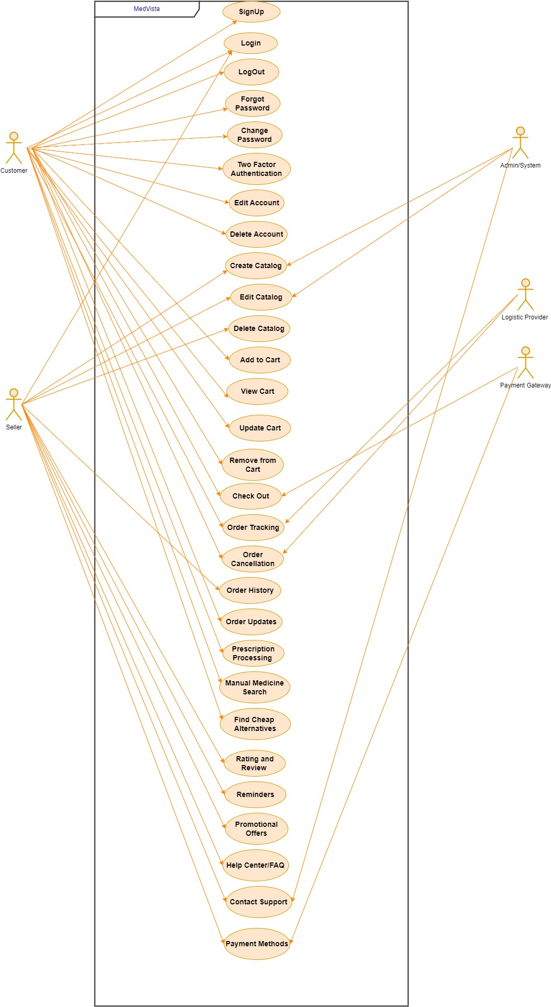

2.4 Fully-dressed Use Cases

SignUp
Table 2.3: Use Case 1
Use Case ID: | UC-01
Use Case Name: | SignUp
Created By: | Ahtasham Sajawal | Last Updated By: | Ahtasham Sajawal
Date Created: | May 10, 2024 | Last Revision Date: | May 11 ,2024
Actors: | - User  - Seller
Description: | The system allows new users to register by providing their email or phone number and selecting a secure password. A verification code is sent via email or SMS for validation.
Trigger: | Click “Sign Up” button on screen.
Preconditions: | User must have access to a valid email or phone number.
Post conditions: | User account is created and verified. User can now log in.
Normal Flow: | User selects the "SignUp" option.  System prompts user to enter email/phone and  password.  User enters the required details.  System sends a verification code to the provided  email/ phone.  User enters the verification code.  System verifies the code and creates the user account. |  |  | System
Alternative Flows: | - Invalid Email/Phone: System displays an error message.  - Invalid Verification Code: User retries with the correct code.
Exceptions: | - Verification code expires. User must request a new code.

Login
Table 2.4: Use Case 2
Use Case ID: | UC-02
Use Case Name: | Login
Created By: | Ahtasham Sajawal | Last Updated By: | Ahtasham Sajawal
Date Created: | May 10, 2024 | Last Revision Date: | May 11 ,2024
Actors: | - User  - Seller
Description: | The system authenticates users by validating their credentials against stored data.
Trigger: | Click “Login Account” button on screen.
Preconditions: | User must have a registered account.
Post conditions: | User is authenticated and granted access to app features.
Normal Flow: | 1. User selects the "Login" option.  2. System prompts for email/phone and password.  3. User enters credentials.  4. System verifies credentials.  5. User is logged in and taken to the home screen. |  |  | System
Alternative Flows: | Invalid Credentials: System displays an error message.
Exceptions: | System temporarily locks account after multiple failed attempts.

Logout
Table 2.5: Use Case 3
Use Case ID: | UC-03
Use Case Name: | Logout
Created By: | Ahtasham Sajawal | Last Updated By: | Ahtasham Sajawal
Date Created: | May 10, 2024 | Last Revision Date: | May 11 ,2024
Actors: | - User  - Seller
Description: | The system allows users to reset their password via recovery email or SMS.
Trigger: | Click “Logout” button on screen.
Preconditions: | User must have a registered account.
Post conditions: | User's password is reset. User can log in with the new password
Normal Flow: | 1.User selects "Logout" option.  2. System clears the session.
Alternative Flows: | Invalid Email/Phone: System displays an error message.  Invalid Recovery Code: User retries with correct code.
Exceptions: | Recovery code expires. User must request a new code

Forgot Password
Table 2.6: Use Case 4
Use Case ID: | UC-04
Use Case Name: | Forget Password
Created By: | Ahtasham Sajawal | Last Updated By: | Ahtasham Sajawal
Date Created: | May 10, 2024 | Last Revision Date: | May 11 ,2024
Actors: | - User  - Seller
Description: | The system allows users to reset their password via recovery email or SMS.
Trigger: | Click “Forget Password” button on screen.
Preconditions: | User must have a registered account.
'Post conditions: | User's password is reset. User can log in with the new password
Normal Flow: | 1.User selects "Forgot Password" option.  2. System prompts for email/phone.  3. User enters email/phone.  4. System sends a recovery code.  5. User enters recovery code and new password.  6. System verifies code and updates the password.
Alternative Flows: | Invalid Email/Phone: System displays an error message.
Exceptions: | Recovery code expires. User must request a new code

Change Password
Table 2.7: Use Case 5
Use Case ID: | UC-05
Use Case Name: | Change Password
Created By: | Ahtasham Sajawal | Last Updated By: | Ahtasham Sajawal
Date Created: | May 10, 2024 | Last Revision Date: | May 11 ,2024
Actors: | - User  - Seller
Description: | The system allows users to change their password from profile settings.
Trigger: | Click “Change Password” button on screen.
Preconditions: | User must be logged in.
Post conditions: | User's password is updated.
Normal Flow: | 1. User navigates to profile settings.  2. User selects "Change Password".  3. The app prompts for current password and new password.  4. User enters the passwords.  5. The app verifies current password and updates to the new password.
Alternative Flows: | Incorrect Current Password: The app displays an error message.
Exceptions: | N/A

Two-Factor Authentication (2FA)

Table 2.8: Use Case 6
Use Case ID: | UC-06
Use Case Name: | Two-Factor Authentication (2FA)
Created By: | Ahtasham Sajawal | Last Updated By: | Ahtasham Sajawal
Date Created: | May 10, 2024 | Last Revision Date: | May 11 ,2024
Actors: | - User  - Seller
Description: | Enhances security by requiring a secondary form of verification during login.
Trigger: | Click “Forget Password” button on screen.
Preconditions: | User must have a registered account and have 2FA enabled.
Post conditions: | User is authenticated with enhanced security.
Normal Flow: | 1. User logs in with email/phone and password.  2. The app prompts for a 2FA code.  3. User enters the 2FA code.  4. The app verifies the 2FA code.  5. User is logged in with enhanced security.
Alternative Flows: | Incorrect 2FA Code: The app displays an error message.
Exceptions: | 2FA code expires. User must request a new code.

Edit Account
Table 2.9: Use Case 7
Use Case ID: | UC-07
Use Case Name: | Edit Account
Created By: | Ahtasham Sajawal | Last Updated By: | Ahtasham Sajawal
Date Created: | May 10, 2024 | Last Revision Date: | May 11 ,2024
Actors: | - User  - Seller
Description: | The system allows users to update their personal information such as email address, phone number, and delivery addresses.
Trigger: | Click “Forget Password” button on screen.
Preconditions: | User must be logged in.
Post conditions: | User's account information is updated.
Normal Flow: | 1. User navigates to profile settings.  2. User selects "Edit Account".  3. The app prompts user to enter new information.  4. User enters the new information.  5. The app validates and updates the information.
Alternative Flows: | Invalid Information: The app displays an error message.
Exceptions: | N/A

Delete Account
Table 2.10: Use Case 8
Use Case ID: | UC-08
Use Case Name: | Delete Account
Created By: | Ahtasham Sajawal | Last Updated By: | Ahtasham Sajawal
Date Created: | May 10, 2024 | Last Revision Date: | May 11 ,2024
Actors: | - User  - Seller
Description: | The system allows users to permanently delete their account, ensuring all user data is securely removed from the database..
Trigger: | Click “Delete Account” button on screen.
Preconditions: | User must be logged in.
Post conditions: | User's account and data are permanently deleted.
Normal Flow: | 1. User navigates to profile settings.  2. User selects "Delete Account".  3. The app prompts for confirmation.  4. User confirms deletion.  5. The app deletes the user account and data.
Alternative Flows: | User Cancels Deletion: Account is not deleted.
Exceptions: | N/A

Create Listing
Table 2.11: Use Case 9
Use Case ID: | UC-09
Use Case Name: | Create Listing
Created By: | Ahtasham Sajawal | Last Updated By: | Ahtasham Sajawal
Date Created: | May 10, 2024 | Last Revision Date: | May 11 ,2024
Actors: | - User  - Seller
Description: | The system allows sellers to create a listing for medicines they wish to sell or donate.
Trigger: | Click “Create Listing” button on screen.
Preconditions: | Seller must have a verified account.
Post conditions: | A new listing is created in the catalog
Normal Flow: | Seller selects “Create Listing” from the catalog management section.  Seller enters medicine details (name, description, dosage, quantity, expiry date, condition, price, isForDonation).  The app validates the information.  The app creates the listing and adds it to the catalog.  Seller selects “Create Listing” from the catalog management section.
Alternative Flows: | Invalid Information: The app displays an error message.
Exceptions: | N/A

Edit Catalog
Table 2.12: Use Case 10
Use Case ID: | UC-10
Use Case Name: | Edit Catalog
Created By: | Ahtasham Sajawal | Last Updated By: | Ahtasham Sajawal
Date Created: | May 10, 2024 | Last Revision Date: | May 11 ,2024
Actors: | - User  - Seller
Description: | The system allows users to update existing listings to ensure accurate information.
Trigger: | Click “Edit Catalog” button on screen.
Preconditions: | Seller must have a verified account.
Post conditions: | Medicine listing is updated.
Normal Flow: | 1. User navigates to catalog management.  2. User selects a listing to edit.  3. The app prompts for updated details.  4. User enters the new details.  5. The app verifies the details and updates the listing.
Alternative Flows: | Invalid Details: The app displays an error message.
Exceptions: | N/A

Delete Catalog

Table 2.13: Use Case 11
Use Case ID: | UC-11
Use Case Name: | Delete Catalog
Created By: | Ahtasham Sajawal | Last Updated By: | Ahtasham Sajawal
Date Created: | May 10, 2024 | Last Revision Date: | May 11 ,2024
Actors: | - User  - Seller
Description: | The system allows users to remove listings that are no longer available.
Trigger: | Click “Delete Catalog” button on screen.
Preconditions: | Seller must have a verified account.
Post conditions: | Medicine listing is removed
Normal Flow: | 1. User navigates to catalog management.  2. User selects a listing to delete.  3. The app prompts for confirmation.  4. User confirms deletion.  5. The app deletes the listing.
Alternative Flows: | User Cancels Deletion: Listing is not deleted.
Exceptions: | N/A

Prescription Processing
Table 2.14: Use Case 11
Use Case ID: | UC-11
Use Case Name: | Prescription Processing
Created By: | Ahtasham Sajawal | Last Updated By: | Ahtasham Sajawal
Date Created: | May 10, 2024 | Last Revision Date: | May 11 ,2024
Actors: | - User  - Seller
Description: | The system allows users to scan prescriptions using the built-in camera, which extracts medicine names and dosages for easier management.
Trigger: | Click “Prescription Processing” button on screen.
Preconditions: | User has a prescription
Post conditions: | Prescription information is extracted and saved.
Normal Flow: | 1. User selects "Prescription Processing".  2. The app prompts to use the camera.  3. User scans the prescription.  4. The app extracts medicine names and dosages.  5. The app saves the extracted information.
Alternative Flows: | Poor Scan Quality: The app prompts to re-scan.
Exceptions: | N/A

Manual Medicine Search
Table 2.15: Use Case 12
Use Case ID: | UC-12
Use Case Name: | Manual Medicine Search
Created By: | Ahtasham Sajawal | Last Updated By: | Ahtasham Sajawal
Date Created: | May 10, 2024 | Last Revision Date: | May 11 ,2024
Actors: | - User  - Seller
Description: | Enables users to manually search for medicines and compare prices.
Trigger: | Click “Manual Medicine Search” button on screen.
Preconditions: | User has login
Post conditions: | Medicine search results are displayed.
Normal Flow: | 1. User selects "Manual Medicine Search".  2. The app prompts for medicine details.  3. User enters the medicine name or other details.  4. The app searches and displays results.
Alternative Flows: | No Results Found: The app displays a no results message.
Exceptions: | N/A

Find Cheap Alternatives
Table 2.15: Use Case 13
Use Case ID: | UC-13
Use Case Name: | Find Cheap Alternatives
Created By: | Ahtasham Sajawal | Last Updated By: | Ahtasham Sajawal
Date Created: | May 10, 2024 | Last Revision Date: | May 11 ,2024
Actors: | - User  - Seller
Description: | The system allows users to search for cost-effective substitutes for their prescribed medications.
Trigger: | Click “Find cheap alternatives” button on screen.
Preconditions: | User must have a prescription or medicine name.
Post conditions: | Medicine search results are displayed.
Normal Flow: | 1. User selects "Find Cheap Alternatives".  2. The app prompts for medicine details.  3. User enters the medicine name or prescription details.  4. The app searches and displays alternative medicines.
Alternative Flows: | No Alternatives Found: The app displays a no alternatives message.
Exceptions: | N/A

Add to Cart
Table 2.16: Use Case 14
Use Case ID: | UC-14
Use Case Name: | Add to cart
Created By: | Ahtasham Sajawal | Last Updated By: | Ahtasham Sajawal
Date Created: | May 10, 2024 | Last Revision Date: | May 11 ,2024
Actors: | - User  - Seller
Description: | The system allows users to select medicines from search results or listings and add them to their cart.
Trigger: | Click “Add to cart” button on screen.
Preconditions: | User must be login
Post conditions: | Selected medicine is added to the cart.
Normal Flow: | 1. User selects a medicine to add to cart.  2. The app prompts for quantity.  3. User enters quantity.  4. The app adds the medicine to the cart.
Alternative Flows: | N/A.
Exceptions: | N/A

View Cart
Table 2.17: Use Case 15
Use Case ID: | UC-15
Use Case Name: | View cart
Created By: | Ahtasham Sajawal | Last Updated By: | Ahtasham Sajawal
Date Created: | May 10, 2024 | Last Revision Date: | May 11 ,2024
Actors: | - User  - Seller
Description: | The system allows users to select medicines from search results or listings and add them to their cart.
Trigger: | Click “View cart” button on screen.
Preconditions: | User must be login
Post conditions: | User views cart details.
Normal Flow: | 1. User selects "View Cart".  2. The app displays all items in the cart.
Alternative Flows: | N/A.
Exceptions: | N/A

Update Cart
Table 2.18: Use Case 16
Use Case ID: | UC-16
Use Case Name: | Update cart
Created By: | Ahtasham Sajawal | Last Updated By: | Ahtasham Sajawal
Date Created: | May 10, 2024 | Last Revision Date: | May 11 ,2024
Actors: | - User  - Seller
Description: | Allows users to adjust quantities or remove items in their cart.
Trigger: | Click “Update cart” button on screen.
Preconditions: | User must be login
Post conditions: | Cart is updated with changes.
Normal Flow: | 1. User selects "Update Cart".  2. The app prompts for adjustments (e.g., change quantity, remove item).
Alternative Flows: | N/A.
Exceptions: | N/A

Remove from Cart
Table 2.19: Use Case 17
Use Case ID: | UC-17
Use Case Name: | Remove from cart
Created By: | Ahtasham Sajawal | Last Updated By: | Ahtasham Sajawal
Date Created: | May 10, 2024 | Last Revision Date: | May 11 ,2024
Actors: | - User  - Seller
Description: | Allows users to delete specific medicines from the cart.
Trigger: | Click “Remove from cart” button on screen.
Preconditions: | User must be login
Post conditions: | Selected medicine is removed from the cart.
Normal Flow: | - User selects an item in the cart.  - The app prompts for confirmation.  - User confirms removal.  - The app removes the item from the cart.
Alternative Flows: | N/A
Exceptions: | N/A

Checkout
Table 2.20: Use Case 18
Use Case ID: | UC-18
Use Case Name: | Checkout
Created By: | Ahtasham Sajawal | Last Updated By: | Ahtasham Sajawal
Date Created: | May 10, 2024 | Last Revision Date: | May 11 ,2024
Actors: | - User  - Seller
Description: | Guides users through reviewing their order, entering payment and delivery information, and confirming the purchase.
Trigger: | Click “Checkout” button on screen.
Preconditions: | User must have items in the cart.
Post conditions: | Order is placed and payment is processed.
Normal Flow: | 1. User selects "Checkout".  2. The app displays order summary.  3. User enters payment and delivery information.  4. The app processes the payment.  5. User confirms the purchase.  6. The app places the order.
Alternative Flows: | Payment Failure: The app displays an error message and prompts to retry.
Exceptions: | N/A

Order Tracking
Table 2.21: Use Case 19
Use Case ID: | UC-19
Use Case Name: | Order Tracking
Created By: | Ahtasham Sajawal | Last Updated By: | Ahtasham Sajawal
Date Created: | May 10, 2024 | Last Revision Date: | May 11 ,2024
Actors: | - User  - Seller
Description: | Provides real-time updates on shipment details, estimated delivery times, and relevant tracking numbers.
Trigger: | Click “Order Tracking” button on screen.
Preconditions: | User must have placed an order.
Post conditions: | User can track the status of their order.
Normal Flow: | 1. User selects "Order Tracking".  2. The app displays order status and tracking information.
Alternative Flows: | No Tracking Information Available: The app displays a message indicating the same.
Exceptions: | N/A

Order Cancellation
Table 2.22: Use Case 20
Use Case ID: | UC-20
Use Case Name: | Order Cancellation
Created By: | Ahtasham Sajawal | Last Updated By: | Ahtasham Sajawal
Date Created: | May 10, 2024 | Last Revision Date: | May 11 ,2024
Actors: | - User  - Seller
Description: | Allows users to cancel their pending orders within a specified timeframe.
Trigger: | Click “Order Cancellation” button on screen.
Preconditions: | User must have placed an order that is not yet fulfilled or dispatched.
Post conditions: | Order is cancelled
Normal Flow: | - User selects "Order Cancellation".  - The app displays eligible orders for cancellation.  - User selects an order to cancel.  - The app prompts for confirmation.  - User confirms cancellation.  - The app cancels the order and processes any applicable refunds.
Alternative Flows: | Order Already Dispatched: The app displays an error message.
Exceptions: | N/A

Multiple Payment Methods
Table 2.23: Use Case 21
Use Case ID: | UC-21
Use Case Name: | Multiple Payment Methods
Created By: | Ahtasham Sajawal | Last Updated By: | Ahtasham Sajawal
Date Created: | May 10, 2024 | Last Revision Date: | May 11 ,2024
Actors: | - User  - Seller
Description: | Enables users to choose from various payment options such as credit card, debit card, PayPal, or other electronic payments during checkout.
Trigger: | Click “Multiple Payment Methods” button on screen.
Preconditions: | User must have item in cart.
Post conditions: | User completes the purchase using their preferred payment method.
Normal Flow: | 1. User selects "Checkout".  2. The app prompts for payment method selection.  3. User selects a payment method and enters details.  4. The app processes the payment.  5. User confirms the purchase.  6. The app places the order.
Alternative Flows: | Payment Failure: The app displays an error message and prompts to retry.
Exceptions: | N/A

Chapter 3

System Design

3.1. Class Diagram

The Medicines System manages users, medicines, orders, carts, and prescriptions, enabling seamless interaction for admins and customers. The User Class, serving as the foundation, stores essential user details like ID, email, and CNIC, with methods like CNIC verification, and is inherited by the Admin Class and Customer Class. Admins handle system-wide operations, including managing the medicine catalog (adding, updating, or deleting medicines), verifying customers, and sending notifications, while customers manage cart items, place orders, view order history, and upload prescriptions for regulated medicines. The Medicine Class stores detailed information about medicines, including alternatives for customer convenience. The Cart Class holds selected items through CartItem objects, allowing customers to add, remove, and calculate totals, clearing upon order placement. The Order Class records customer orders with details like ID, items, total, and status, enabling tracking. Admins notify users via the Notification Class, and the Prescription Class manages uploaded prescriptions, ensuring compliance for regulated medicines. Together, these components create a robust, user-friendly system for efficient medicine management.

Figure 3.1: Class Diagram
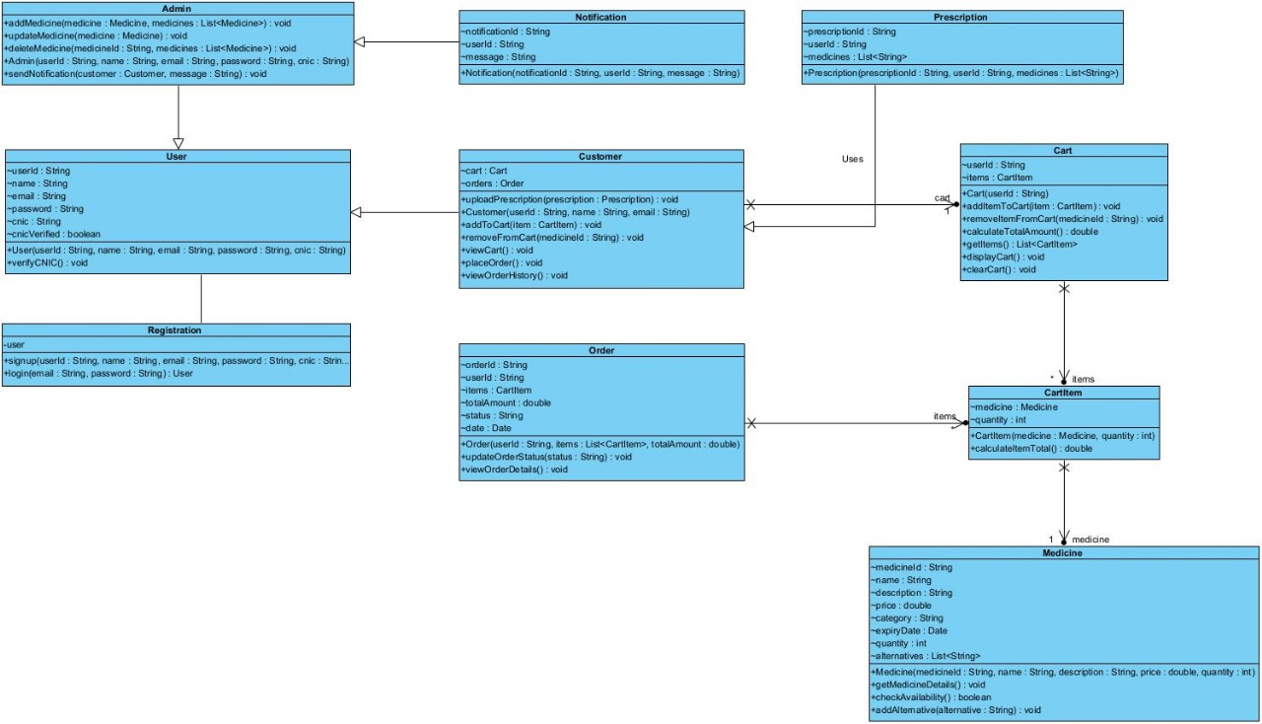

3.2. Sequence Diagram

The user logs into the system through the frontend interface (web app), which sends login credentials to the backend for verification against the database. Upon successful verification, the user gains access. If logged in as an admin, the user can add medicines to the system by sending medicine details via a POST request from the frontend to the backend, which saves the data in the database and returns a success message. Users can browse available medicines, with the frontend fetching the list from the backend, which retrieves the data from the database and displays it to the user. For cart management, users add items to the cart by selecting medicines and sending the selection and quantities to the backend, which updates the cart in the database and confirms the update. During order placement, the user submits cart data along with address and payment details to the backend, which saves the order, adjusts medicine quantities in the database, and confirms successful order placement.
Figure 3.2: Sequence Diagram
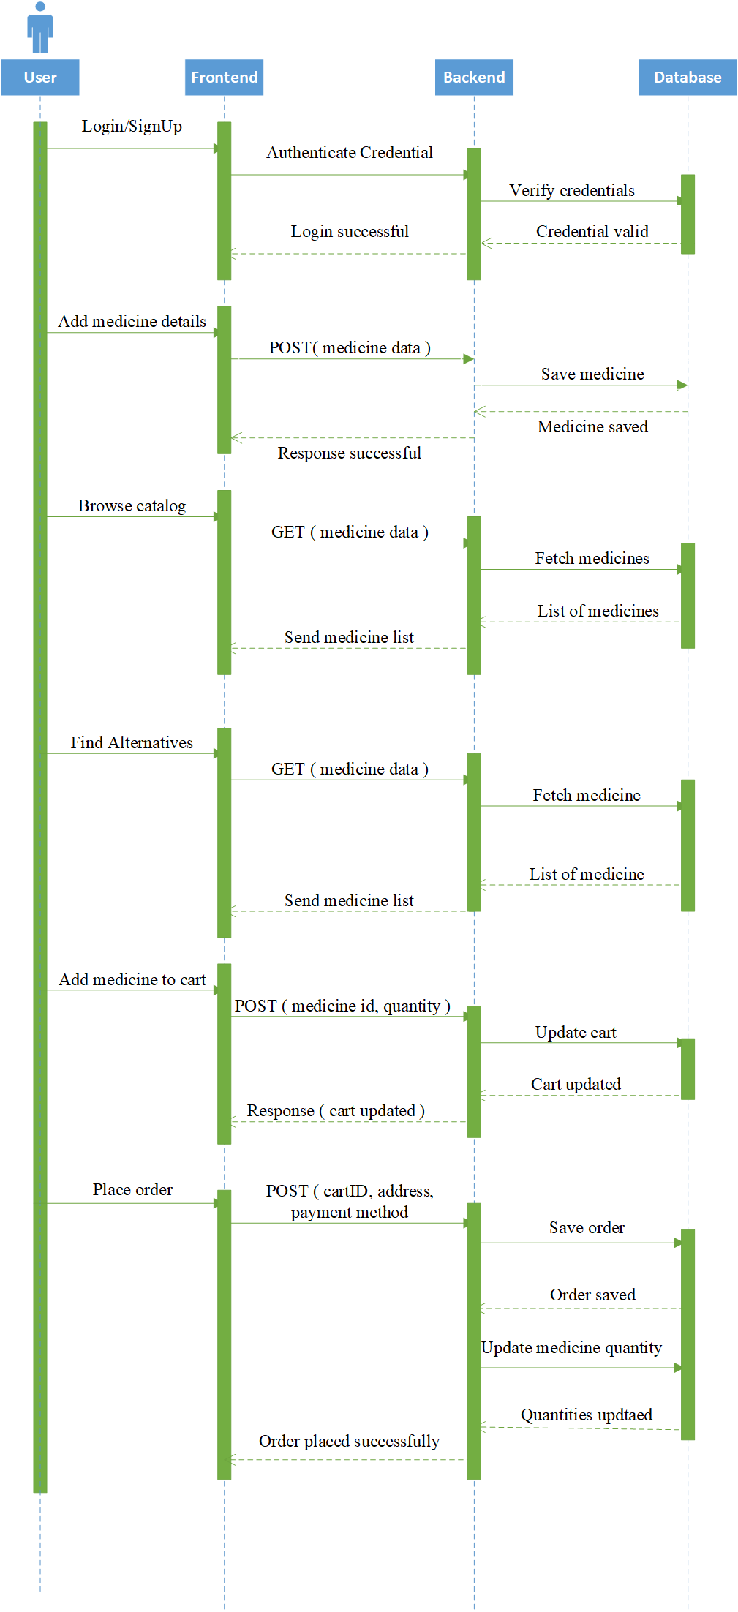

3.3. System Sequence Diagram

Sign Up
The Sign Up enables new users to create an account by providing necessary details, such as an email, password, and personal information. This is the initial step for users to gain access to the system.
Figure 3.3.1: System Sequence Diagram 1
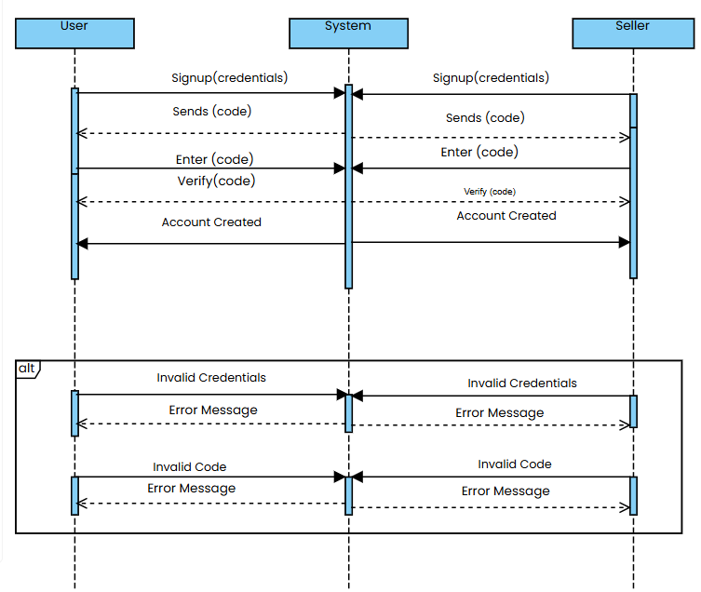

Login
The Login allows existing users to access their accounts by entering their login credentials (such as email and password). The system verifies the details, including optional two-factor authentication, and grants access upon successful validation. Successful login grants access to all user-specific features and data.
Figure 3.3.2: System Sequence Diagram 2
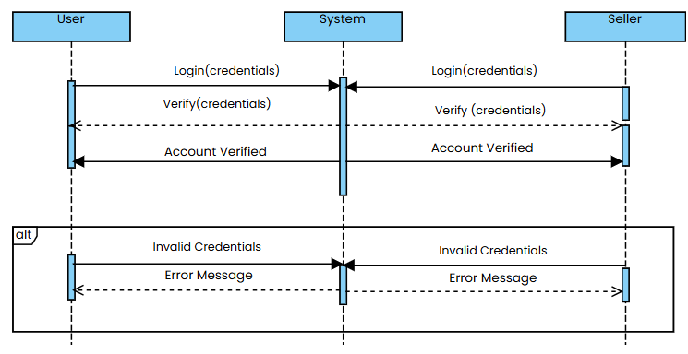
Log out
The Logout provides users with a secure way to exit their account. This action ends the user session, helping to protect sensitive information, especially on shared devices.
Figure 3.3.3: System Sequence Diagram 3
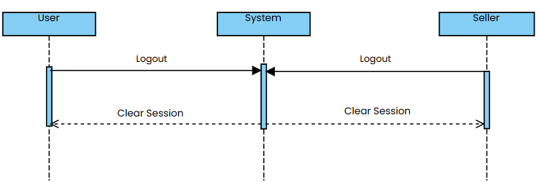

Forget password
In the Forgot Password, users who have forgotten their login credentials can reset their password. The system sends a recovery code to the user's registered email or phone number to confirm their identity before allowing a password reset.
Figure 3.3.4: System Sequence Diagram 4
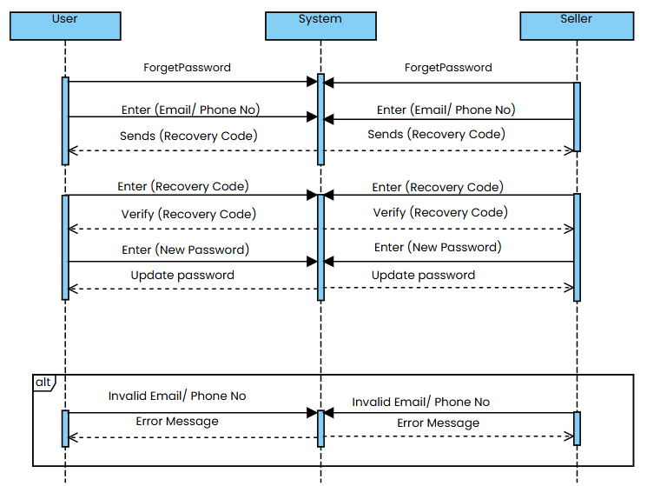
Two-Factor Authentication (2FA)
The 2FA enhances account security by requiring users to enter a secondary code, typically sent to their phone or email, in addition to their password. This adds an extra layer of security to the login process.

Figure 3.3.5: System Sequence Diagram 5
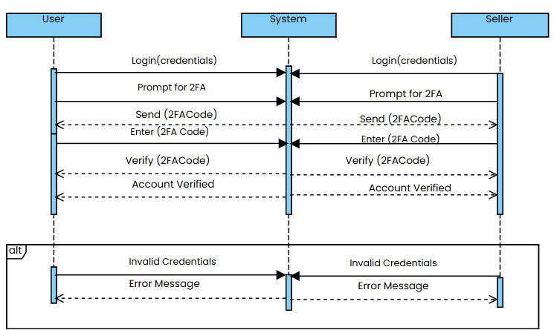
Edit Account
The Edit Account allows users to update their personal information, such as email, address, or phone number. It ensures that user profiles remain current and accurate.
Figure 3.3.6: System Sequence Diagram 6
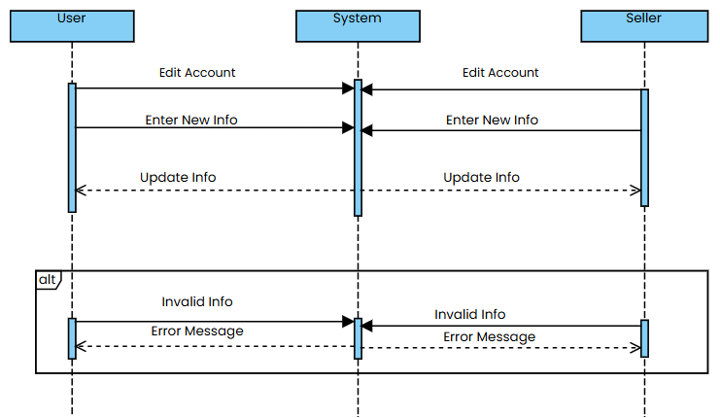
Delete Account
This enables users to permanently delete their account from the system. It removes all user data and access, which is often irreversible.
Figure 3.3.7: System Sequence Diagram 7
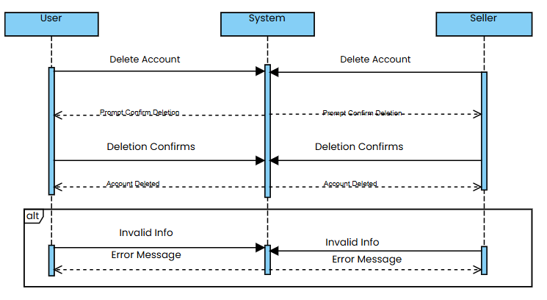
Create Listing
In the Create Listing, users, typically sellers, can add new items (medicines) to their catalog. This listing becomes available for buyers to view and purchase.

Figure 3.3.8: System Sequence Diagram 8
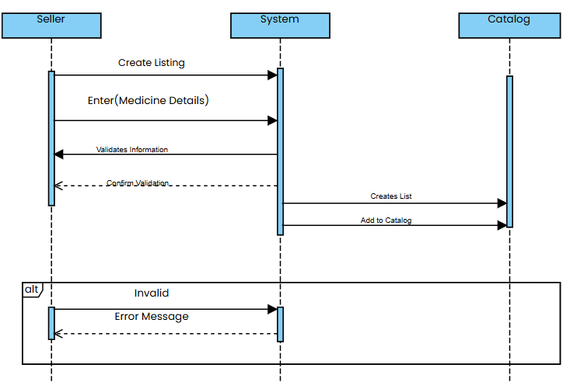
Edit Catalog
The Edit Catalog allows sellers to modify existing listings, such as updating prices, changing descriptions, or adjusting stock quantities, ensuring that the catalog reflects accurate information.

Figure 3.3.9: System Sequence Diagram 9
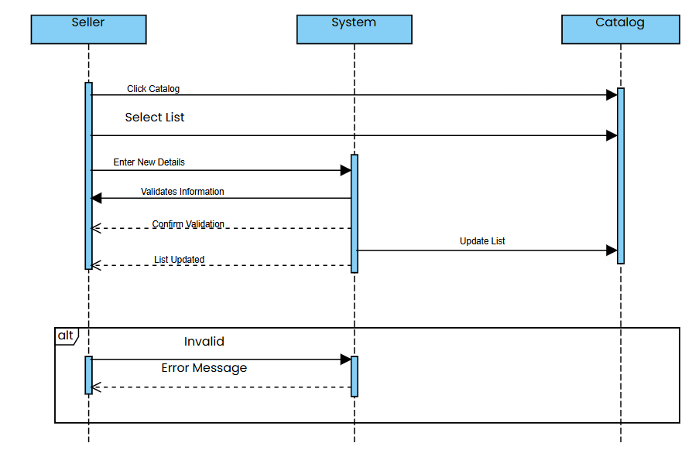Delete Catalog
The Delete Catalog enables sellers to remove specific items from their catalog. This is useful when items are discontinued or out of stock indefinitely.

Figure 3.3.10: System Sequence Diagram 10
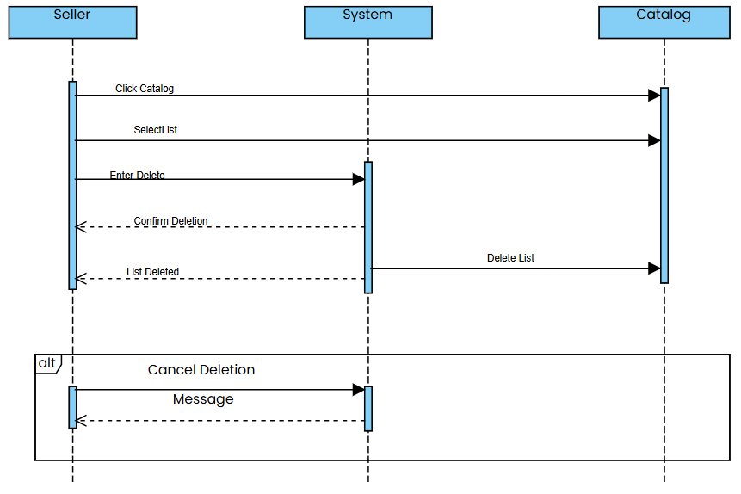
Prescription Processing
In this case, users can upload a prescription, allowing the system to process and extract relevant information. This feature is useful for simplifying the ordering of prescribed medications.

Figure 3.3.11: System Sequence Diagram 11
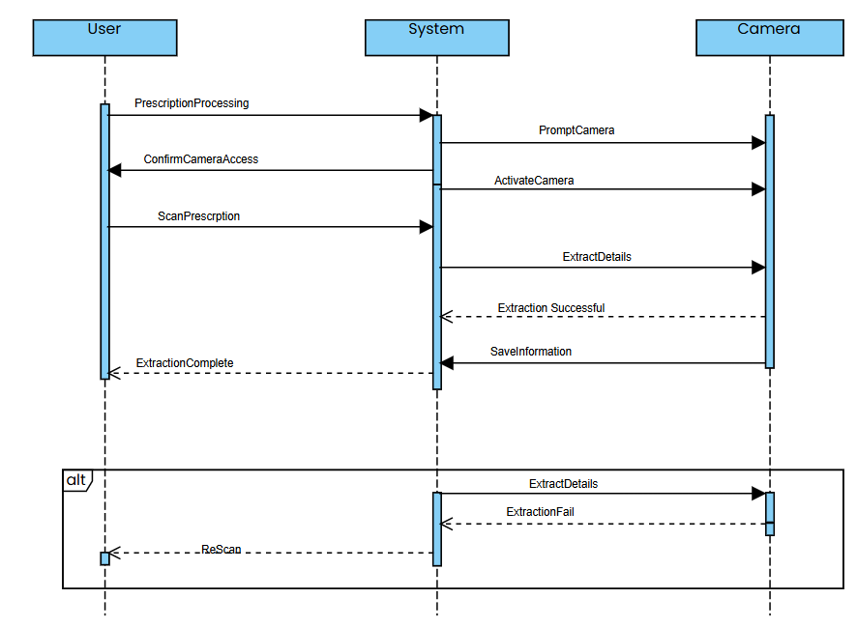
Manual Medicine Search
The Manual Medicine Search enables users to search for specific medicines in the system and view details such as availability and price, making it easier for users to find needed items.

Figure 3.3.12: System Sequence Diagram 12
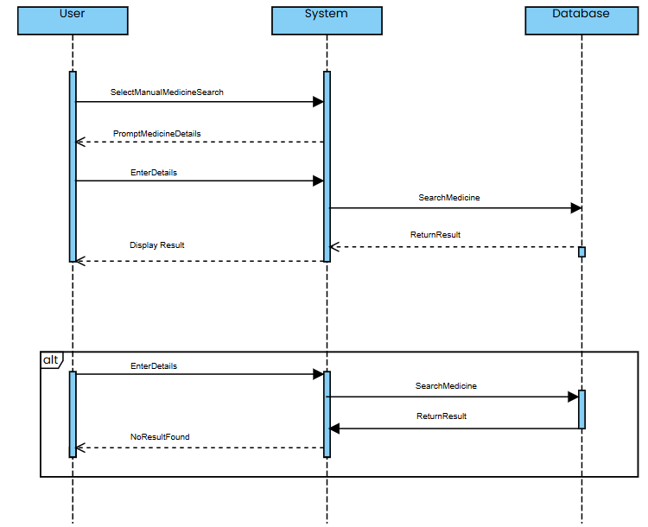
Find Cheap Alternatives
This allows users to search for cheaper alternatives to prescribed medicines. It provides a list of similar medicines that may be more affordable, helping users save on healthcare costs.

Figure 3.3.13: System Sequence Diagram 13
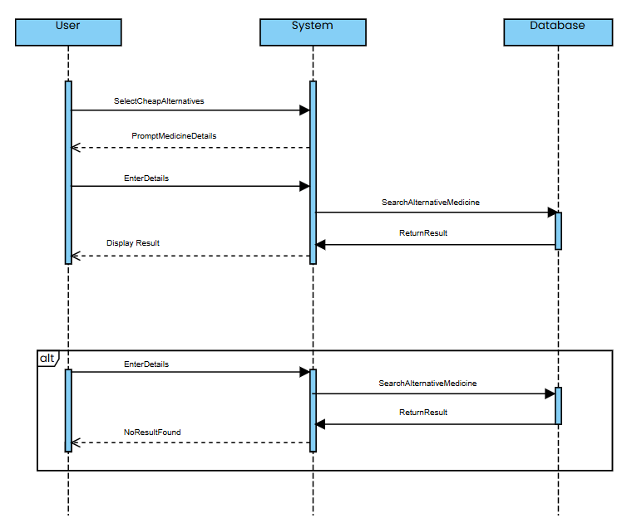
Add to Cart
The Add to Cart lets users add medicines they wish to purchase to their shopping cart, where they can later review and proceed to checkout.

Figure 3.3.14: System Sequence Diagram 14
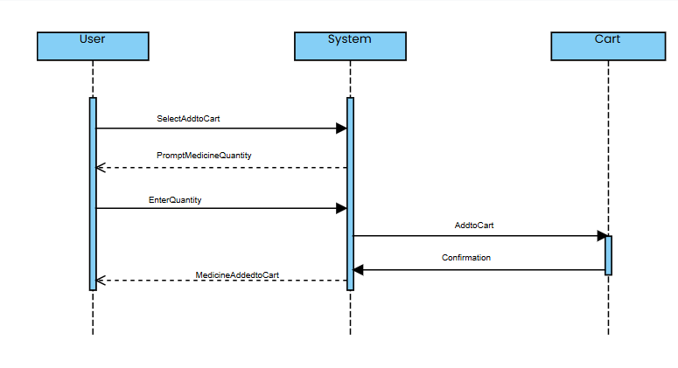
View Cart
In the View Cart, users can review all items currently in their cart. This page displays item details, quantities, and the total price, allowing users to verify their order before checkout.
Figure 3.3.15: System Sequence Diagram 15
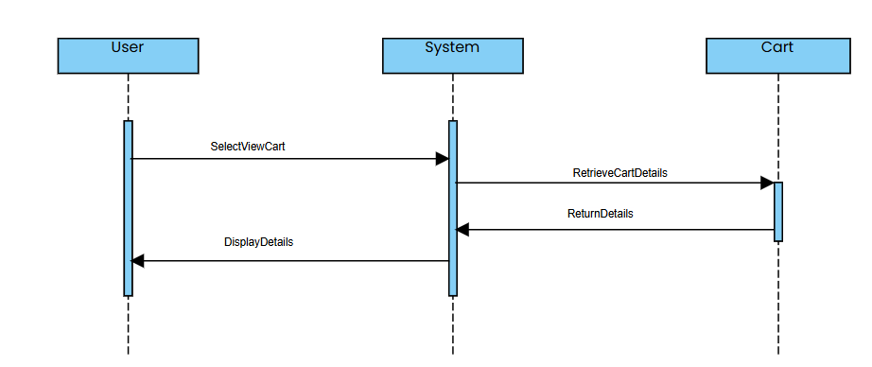

Update Cart
The Update Cart allows users to adjust quantities or remove items from their cart. This flexibility enables users to make changes before finalizing their purchase.
Figure 3.3.16: System Sequence Diagram 16
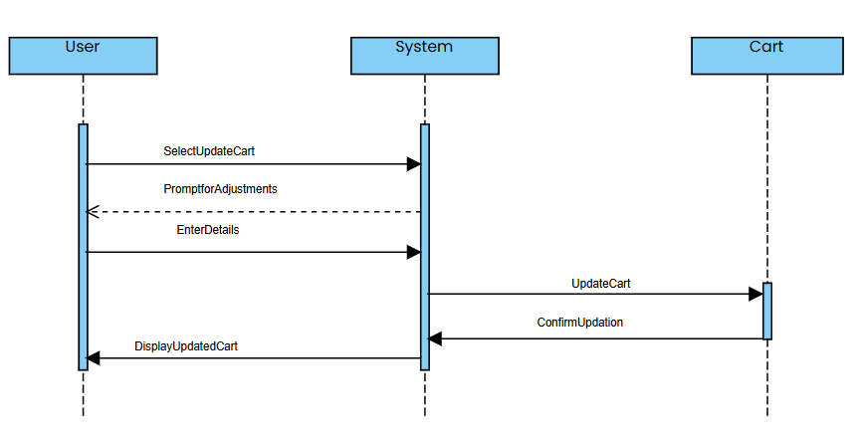
Remove from Cart
This provides users with the option to remove specific items from their cart, which can be helpful when users change their mind about a product.

Figure 3.3.17: System Sequence Diagram 17
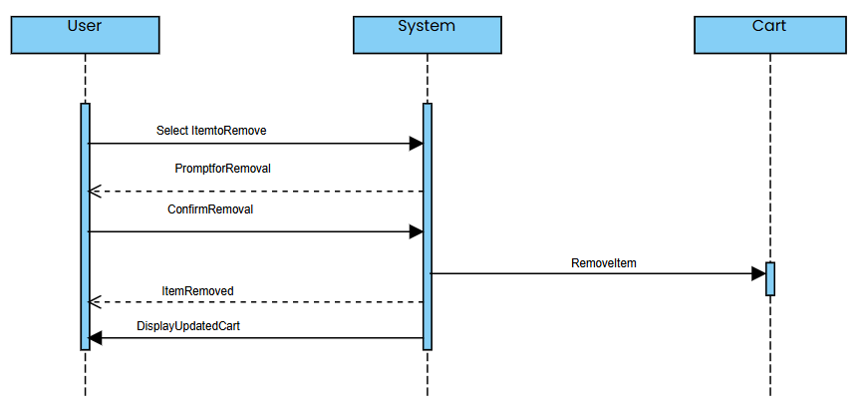
Checkout
The Checkout guides users through reviewing their order, entering payment and delivery information, and confirming the purchase. It is the final step in completing a transaction.

Figure 3.3.18: System Sequence Diagram 18
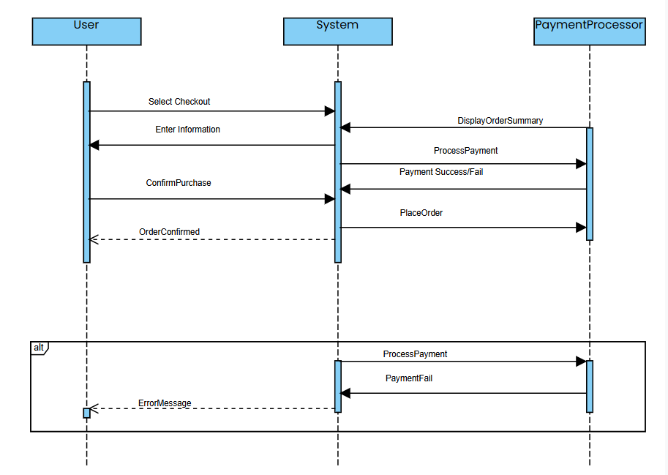
Order Tracking
The Order Tracking provides users with real-time updates on their order’s shipping status, estimated delivery time, and relevant tracking numbers.

Figure 3.3.19: System Sequence Diagram 19
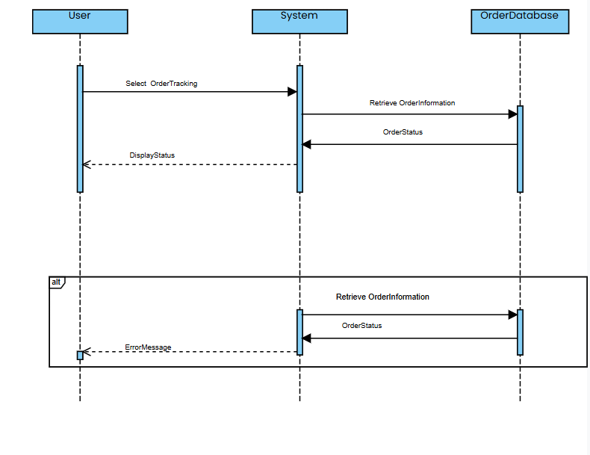
Order cancellation
In this case, users can cancel their pending orders within a specified timeframe if the order has not yet been fulfilled or dispatched.

Figure 3.3.20: System Sequence Diagram 20
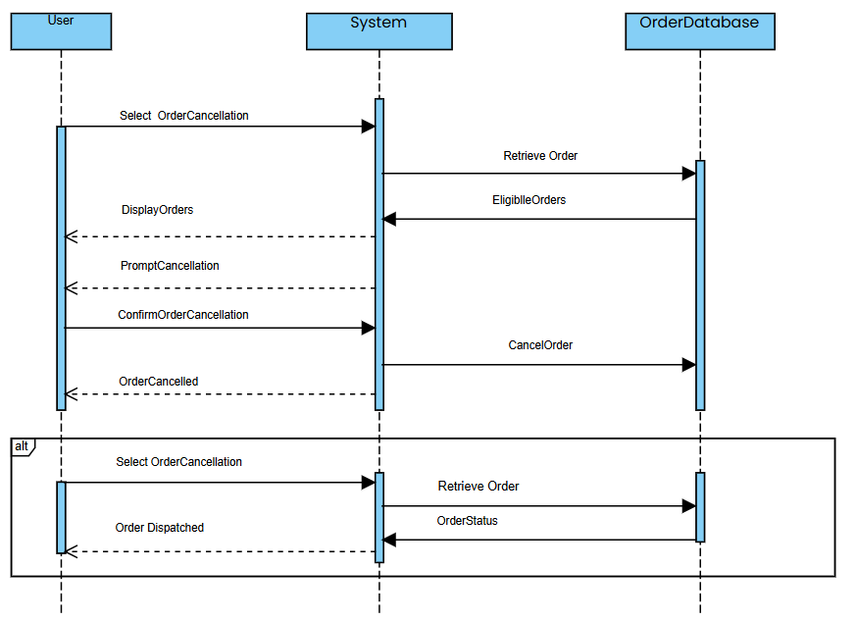
Multiple Payment Methods
This case enables users to choose from various payment options, such as credit card, debit card, or PayPal, during checkout, allowing flexibility in completing their purchase.

Figure 3.3.21: System Sequence Diagram 21
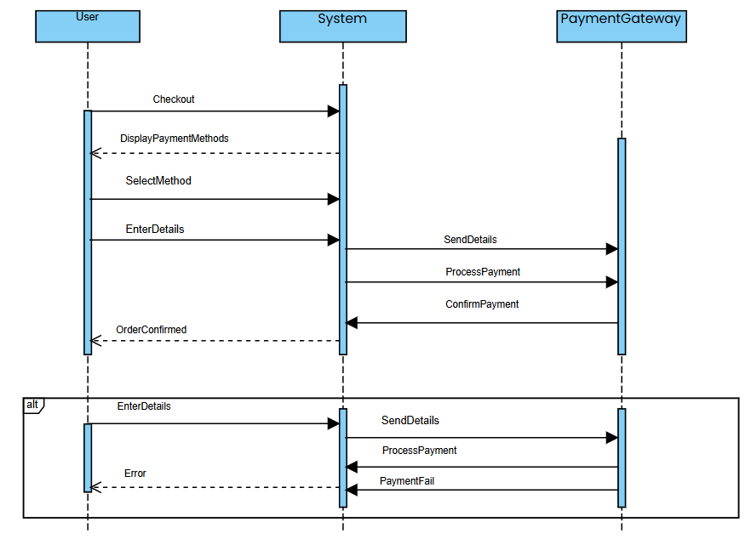

3.4. Activity Diagram

Signup
The Sign Up enables new users to create an account by providing necessary details, such as an email, password, and personal information. This is the initial step for users to gain access to the system. The system validates the information and creates an account. If successful, the system notifies the user of account creation.

Figure 3.4.1: Activity Diagram 1
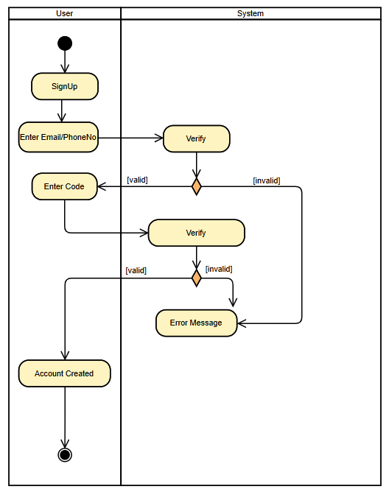

Login
The Login allows existing users to access their accounts by entering their login credentials (such as email and password). The system verifies the details, including optional two-factor authentication, and grants access upon successful validation. Successful login grants access to all user-specific features and data and redirected to the home screen. If incorrect, an error message is displayed.

Figure 3.4.2: Activity Diagram 2
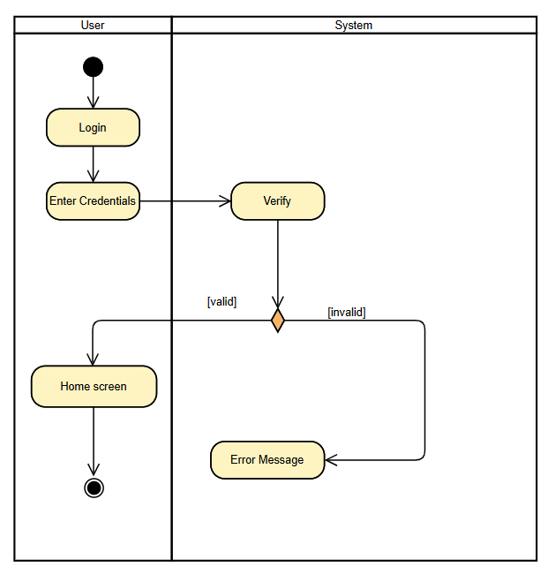

Logout
The Logout provides users with a secure way to exit their account. This action ends the user session, helping to protect sensitive information, especially on shared devices.

Figure 3.4.3: Activity Diagram 3
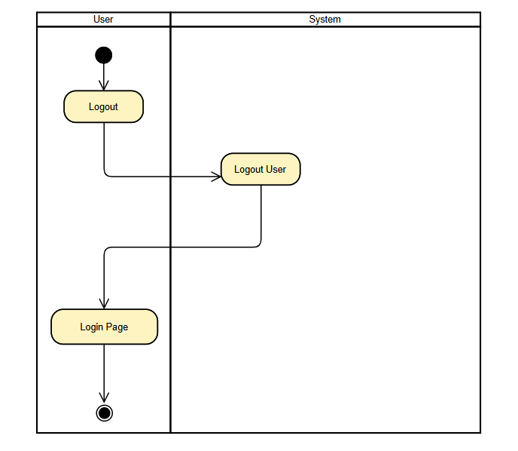
Forget password
In the Forgot Password, users who have forgotten their login credentials can reset their password. The system sends a recovery code to the user's registered email / phone number to confirm their identity before allowing a password reset.

Figure 3.4.4: Activity Diagram 4
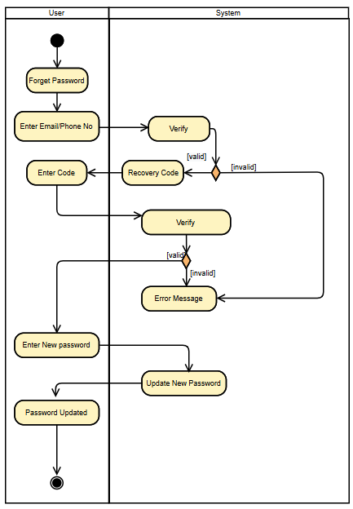

Two-Factor Authentication (2FA)
The 2FA enhances account security by requiring users to enter a secondary code, typically sent to their phone or email, in addition to their password. This adds an extra layer of security to the login process.

Figure 3.4.5: Activity Diagram 5
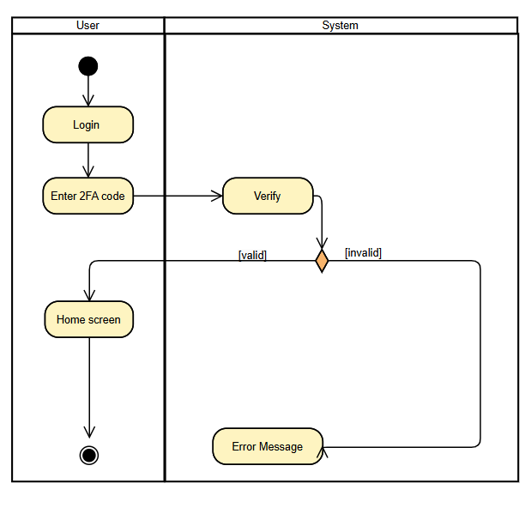
Edit Account
The Edit Account allows users to update their personal information, such as email, address, or phone number. It ensures that user profiles remain current and accurate.

Figure 3.4.6: Activity Diagram 6
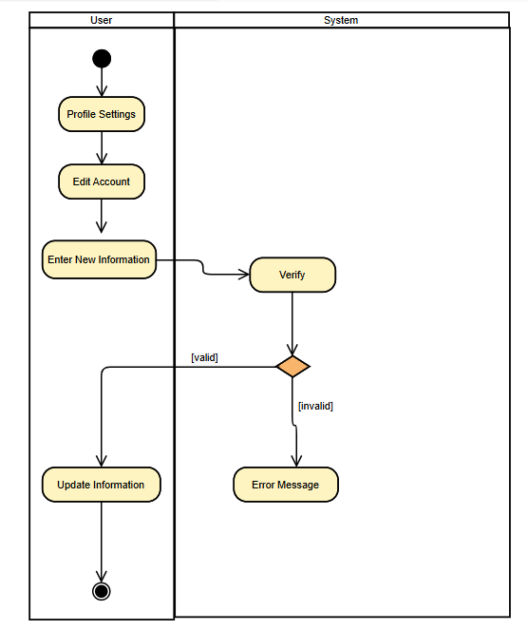

Delete Account
This enables users to permanently delete their account from the system. It removes all user data and access, which is often irreversible.

Figure 3.4.7: Activity Diagram 7
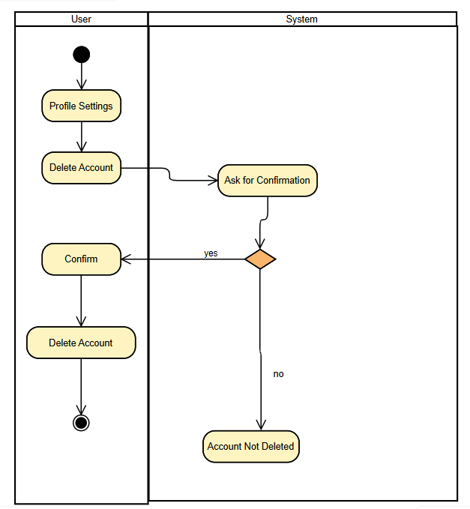
Create listing
In the Create Listing, users, typically sellers, can add new items (medicines) to their catalog. This listing becomes available for buyers to view and purchase.

Figure 3.4.8: Activity Diagram 8
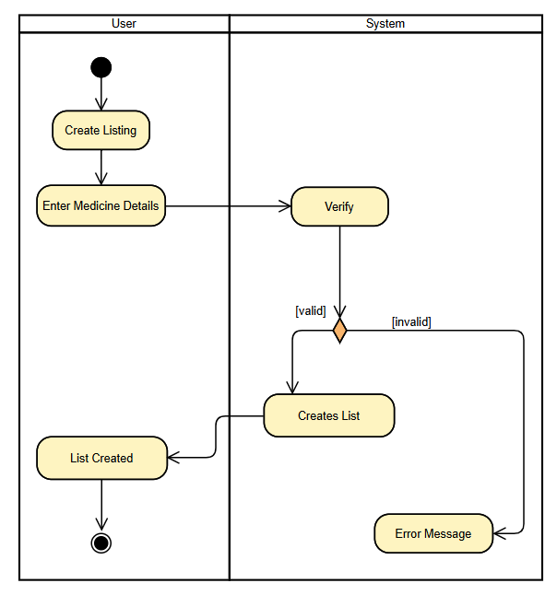
Edit Catalog
The Edit Catalog allows sellers to modify existing listings, such as updating prices, changing descriptions, or adjusting stock quantities, ensuring that the catalog reflects accurate information.

Figure 3.4.9: Activity Diagram 9
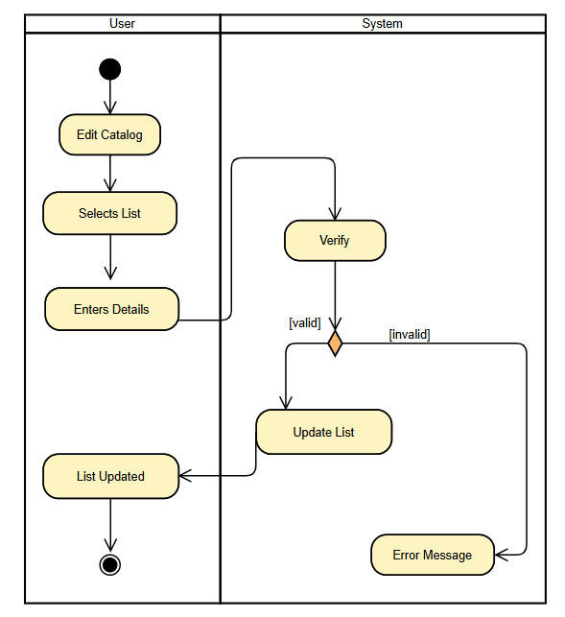
Delete Catalog
The Delete Catalog enables sellers to remove specific items from their catalog. This is useful when items are discontinued or out of stock indefinitely.

Figure 3.4.10: Activity Diagram 10
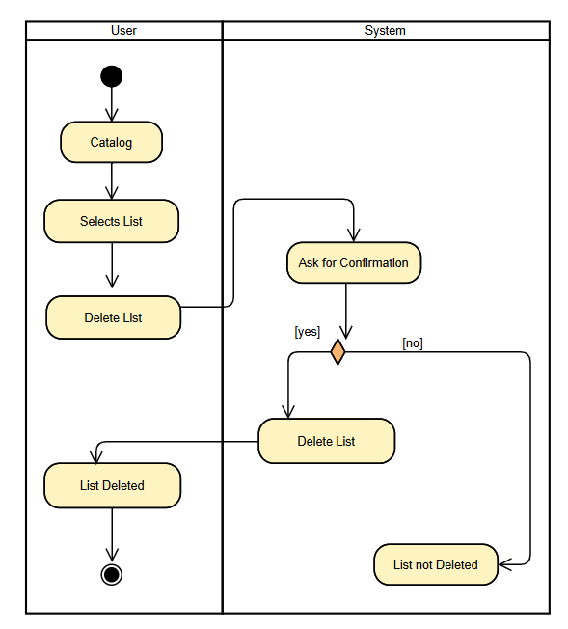
Prescription Processing
In this, users can upload a prescription, allowing the system to process and extract relevant information. If the quality of scanning is better, information is extracted and displayed. If not, the system asks for re-scanning. This feature is useful for simplifying the ordering of prescribed medications.

Figure 3.4.11: Activity Diagram 11
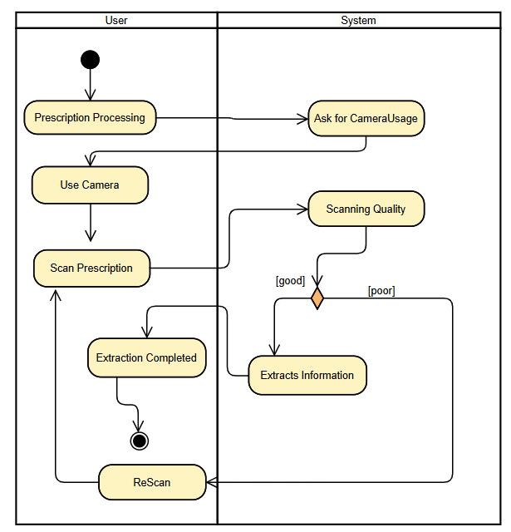

Manual Medicine Search
The Manual Medicine Search enables users to search for specific medicines in the system and view details such as availability and price, making it easier for users to find needed items. If the medicine is available, results are displayed otherwise a message showing no result found is displayed.

Figure 3.4.12: Activity Diagram 12
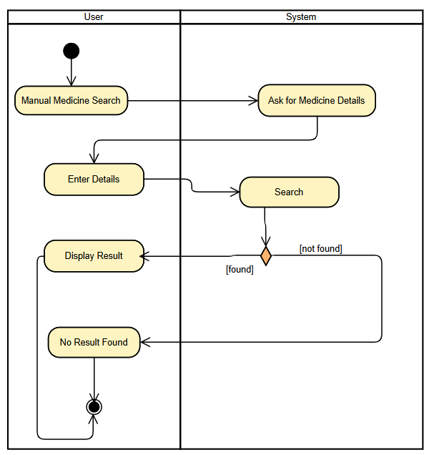

Find Cheap Alternatives
This allows users to search for cheaper alternatives to prescribed medicines. It provides a list of similar medicines that may be more affordable if present, helping users save on healthcare costs. Otherwise, a message showing no alternative found is displayed.

Figure 3.4.13: Activity Diagram 13
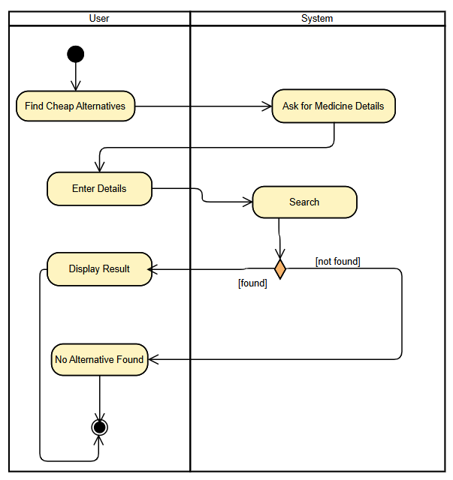

Add to Cart
The Add to Cart lets users add medicines they wish to purchase to their shopping cart, where they can later review and proceed to checkout.

Figure 3.4.14: Activity Diagram 14
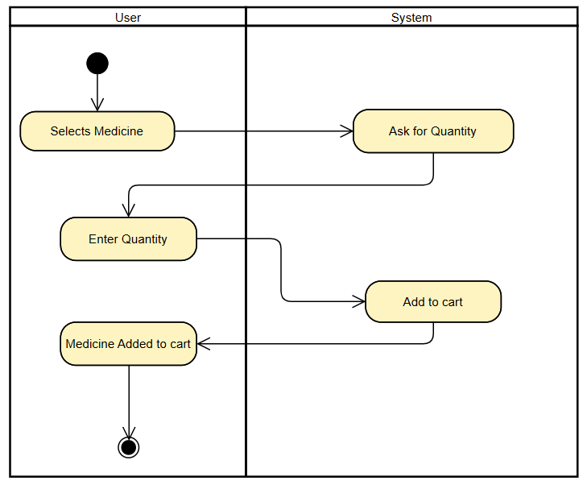

View Cart
In the View Cart, users can review all items currently in their cart. This page displays item details, quantities, and the total price, allowing users to verify their order before checkout.

Figure 3.4.15: Activity Diagram 15
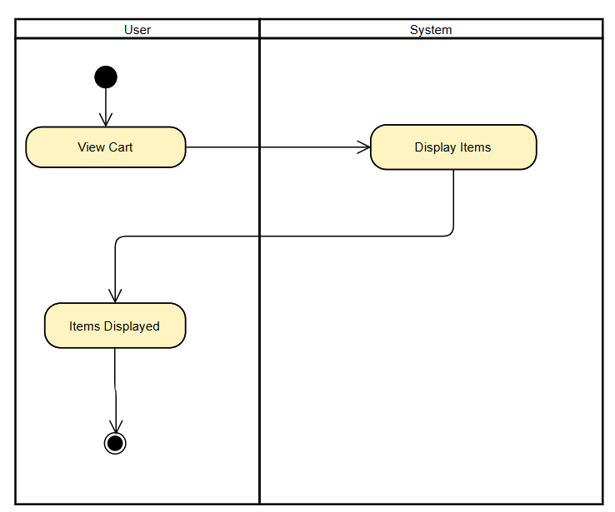

Update Cart
The Update Cart allows users to adjust quantities or remove items from their cart. This flexibility enables users to make changes before finalizing their purchase.

Figure 3.4.16: Activity Diagram 16
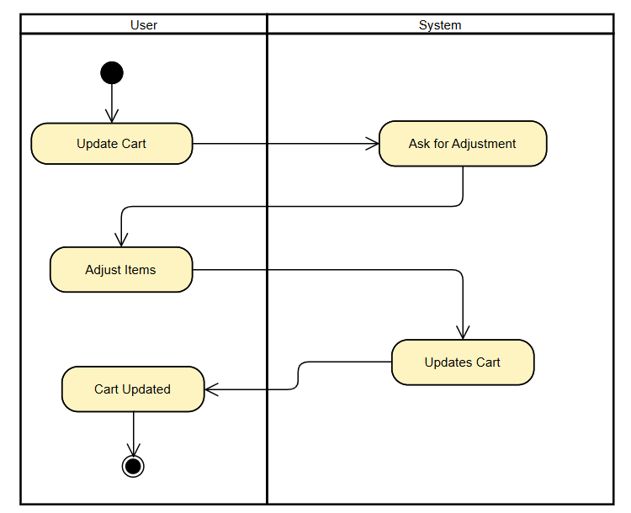

Remove from Cart
This provides users with the option to remove specific items from their cart, which can be helpful when users change their mind about a product.

Figure 3.4.17: Activity Diagram 17
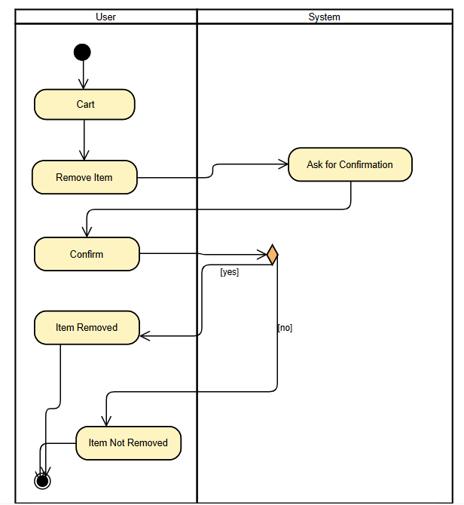

Checkout
The Checkout guides users through reviewing their order, entering payment and delivery information, and confirming the purchase. It is the final step in completing a transaction. If payment is processed successfully, then system proceeds further and places order, otherwise an error message is shown.

Figure 3.4.18: Activity Diagram 18
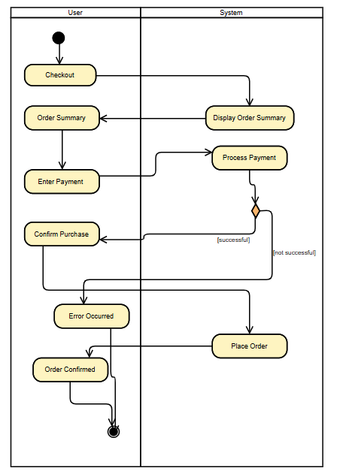

Order Tracking
The Order Tracking provides users with real-time updates on their order’s shipping status, estimated delivery time, and relevant tracking numbers.

Figure 3.4.19: Activity Diagram 19
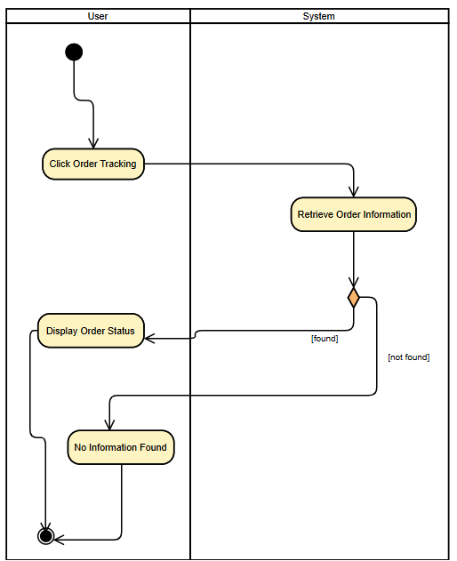

Order Cancellation
In this, users can cancel their pending orders within a specified timeframe if the order has not yet been fulfilled or dispatched.

Figure 3.4.20: Activity Diagram 20
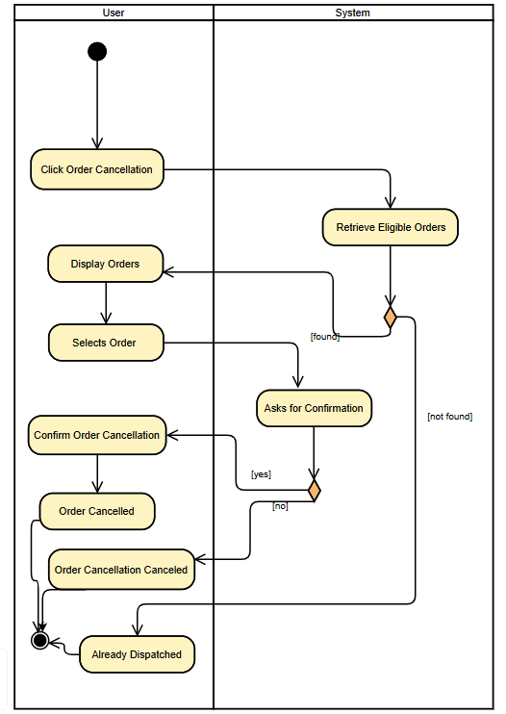

Multiple Payment Methods
This enables users to choose from various payment options, such as credit card, debit card during checkout, allowing flexibility in completing their purchase.

Figure 3.4.21: Activity Diagram 21
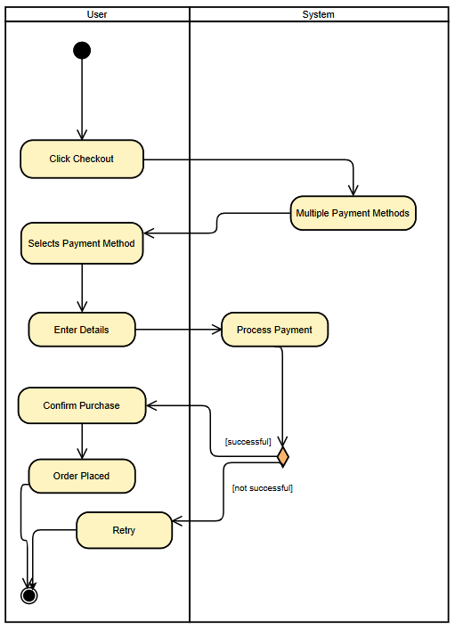

3.5. State Transition Diagram

This state transition diagram illustrates the flow of user interactions within platform for purchasing medicines. Starting with authentication, users can sign up or log in, followed by verification to secure access. Once logged in, users reach the home screen, where they can manage their profile, view the catalog, process prescriptions, or manually search for items. Upon selecting an item, users can add it to their cart with options to adjust quantities. They can then view or edit the cart and proceed to checkout, where the payment is processed. After placing an order, users can track their order status, with updates available until fulfillment. At any point, users can log out, returning to the initial state, creating a clear sequence of actions and transitions within the platform.
Figure 3.5: State Transition Diagram
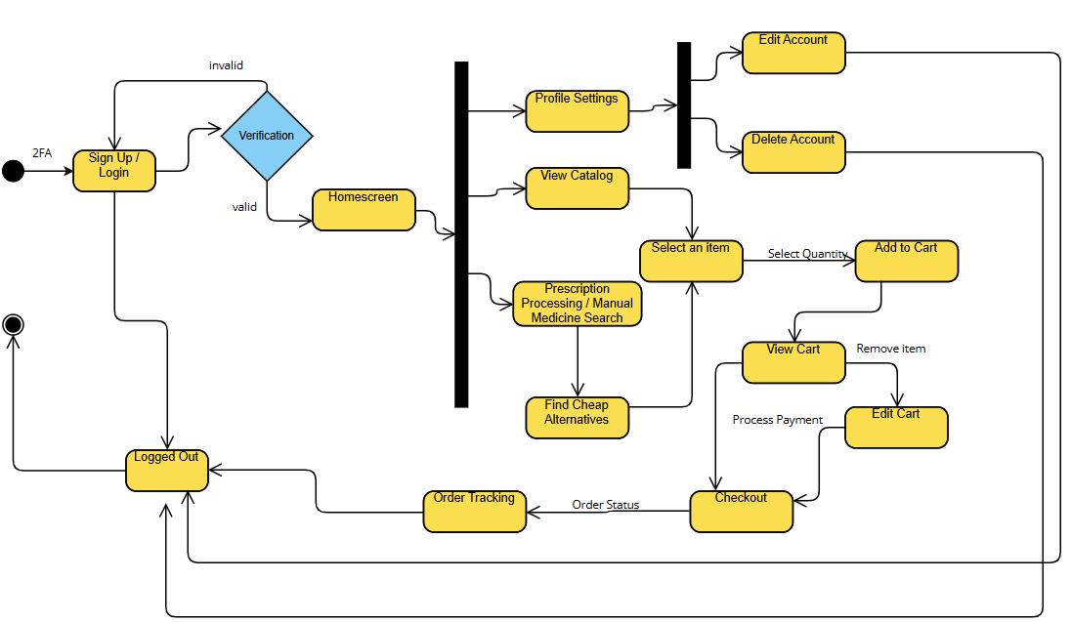

3.6. Database Schema

User Schema: The User schema represents a registered user in the system. It includes essential fields like userId, name, email, and password, which are required for user registration and authentication. Additionally, it has a boolean field isAdmin to distinguish between regular users and administrators, and a cnicVerified flag that helps identify whether a user’s CNIC (National Identity Card) has been verified for admin-level tasks, such as managing medicines. Users also have a cart property that holds the items they add to their shopping cart. The CNIC verification ensures that only valid users can perform sensitive tasks, such as adding or deleting medicines.

Medicine Schema: The Medicine schema is used to define the various medicines available in the system. Each medicine is identified by a unique medicineId and contains details like name, description, price, image, and category, which provide important information to the user. The expiryDate is particularly crucial for ensuring that only valid, non-expired medicines are sold. A key feature of this schema is the alternatives field, which stores a list of other medicines that can serve as alternatives for a particular health issue, providing the user with options in case a specific medicine is out of stock. The quantity field tracks the number of units available for sale.

Order Schema: The Order schema represents a customer’s order in the system. Each order is uniquely identified by an orderId and is linked to a specific user through the userId. The items array stores the medicines purchased in the order, while the amount represents the total price for all items in the order. The address field captures the delivery information, and the status field keeps track of the order’s progress, with possible values such as "Processing", "Shipped", or "Delivered". The payment field indicates whether the payment has been successfully made for the order. This schema enables both customers and admins to track the progress of orders.

Cart Schema: The Cart schema is designed to manage the shopping cart of a user. It associates a user’s userId with the list of items they have added to their cart. Each item in the cart is an object that includes the medicineId (which identifies the medicine) and the quantity (which represents how many units of that medicine the user wants to purchase). The totalAmount field holds the total value of all items in the cart, which is calculated based on the price and quantity of each medicine. This schema facilitates the user’s shopping experience, enabling them to manage items before proceeding with an order.

Prescription Schema: The Prescription schema tracks the details of a prescription issued to a user. Each prescription is identified by a unique prescriptionId and contains information about the medicines prescribed, including their medicineId, dosage, and duration. It also captures the doctorName of the prescribing doctor and the issuedDate, which helps maintain a record of when the prescription was given. This schema is useful for users who require prescribed medicines and can also be used to track the validity of a prescription.

Notification Schema: The Notification schema handles communication with users regarding updates or changes to their orders or account. Each notification is linked to a specific userId and contains a message to inform the user about important updates, such as changes in order status or promotions. The status field keeps track of whether the notification has been read or not, which can be marked as "Sent" or "Read". The dateSent field records when the notification was sent, ensuring that users are updated in a timely manner.

Feedback Schema: The Feedback schema collects feedback from users regarding their orders. Each piece of feedback is identified by a unique feedbackId and is linked to a specific user and order through userId and orderId, respectively. The rating field captures the user’s rating for the product or service, with values ranging from 1 to 5, while the comment field allows the user to provide additional feedback. The date field records when the feedback was given. This schema allows the system to gather valuable insights from users, helping improve service and product offerings.
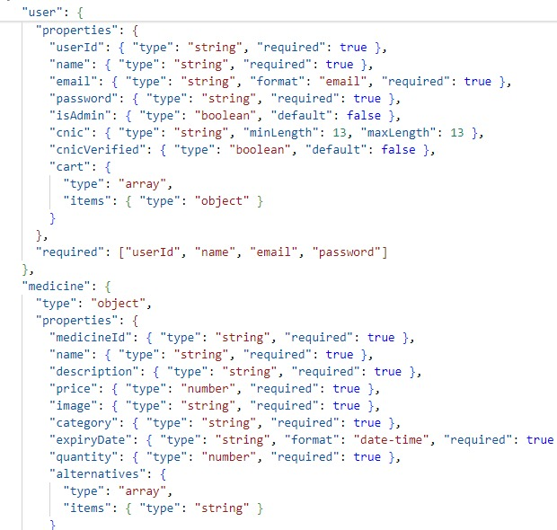
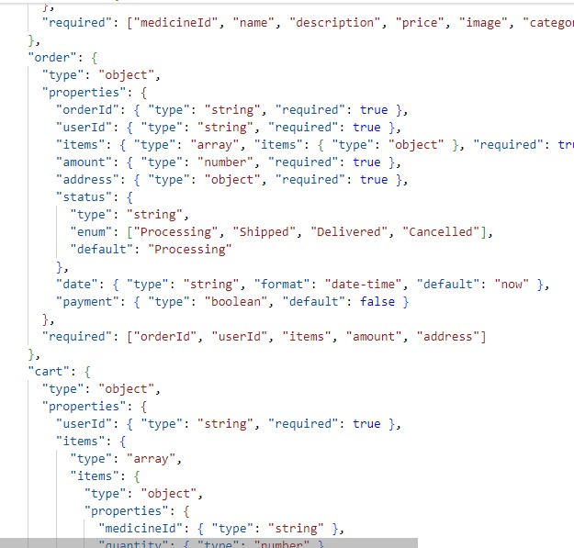
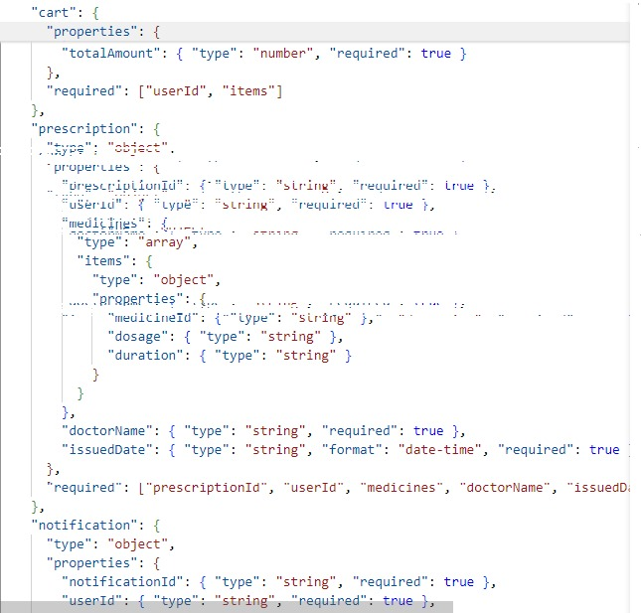
Figure 3.6: Database Schema

3.7. User Interface Design

Main hero section
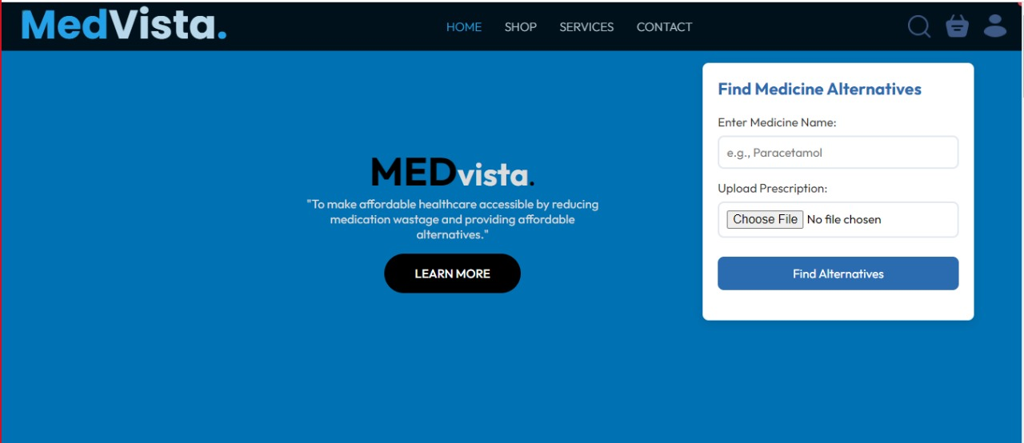
Services section
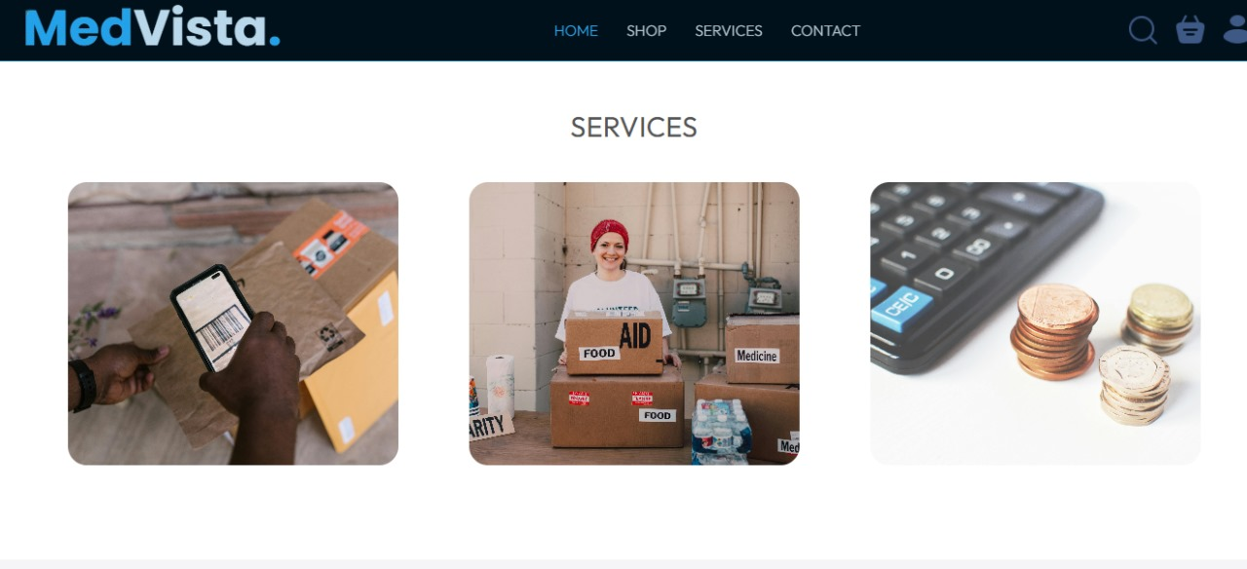
Explore our menu section


Listing section/products
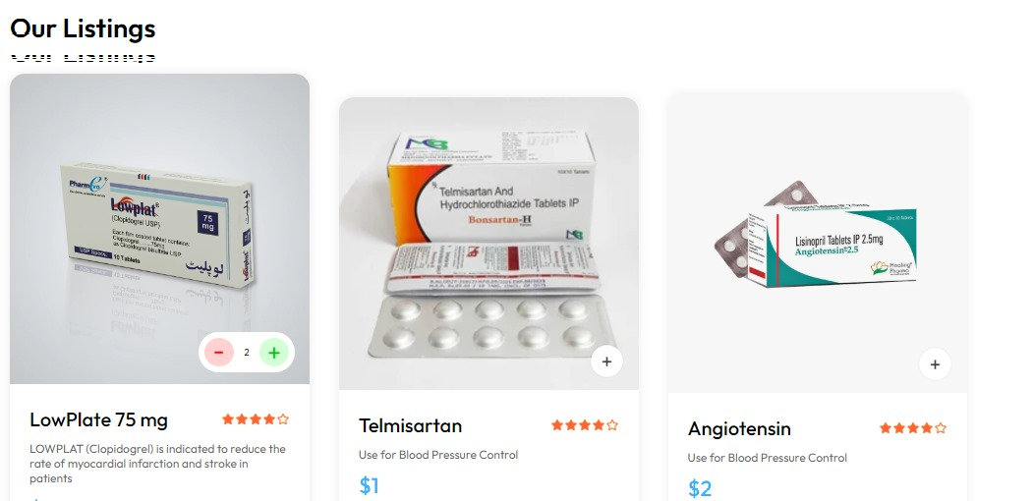
About us
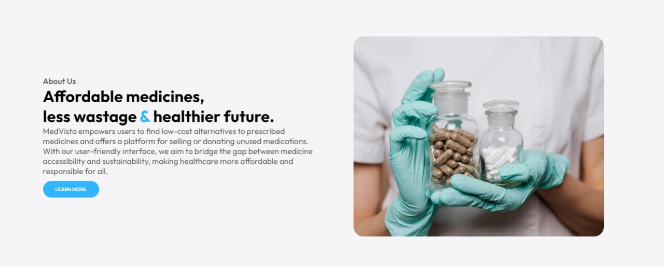

Contact Us

Admin Panel ( listed medicines )
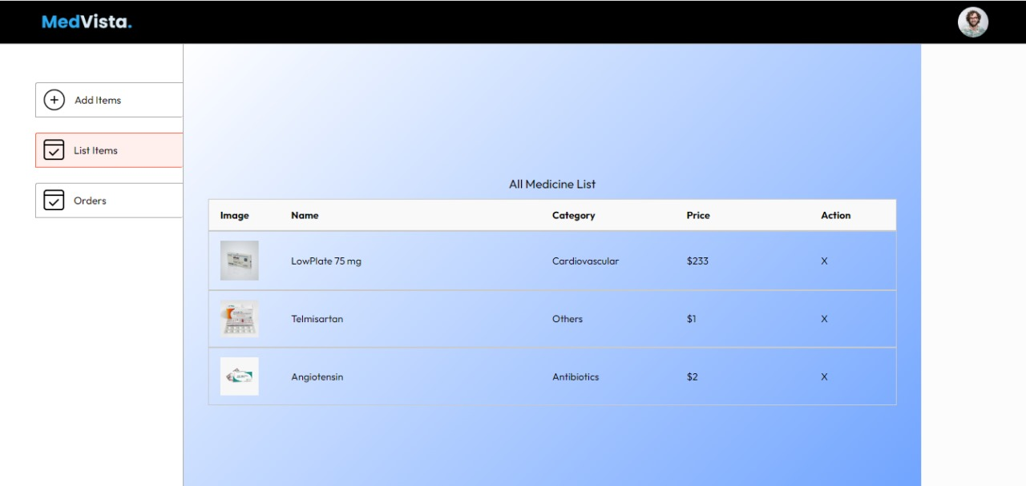

Admin panel ( order history )
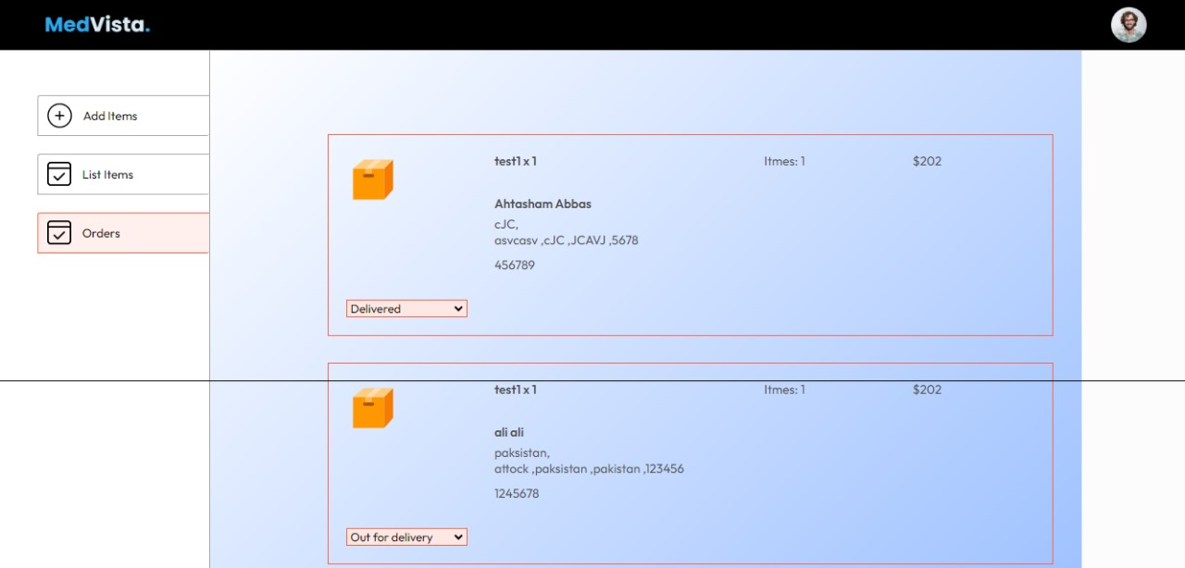

Checkout page
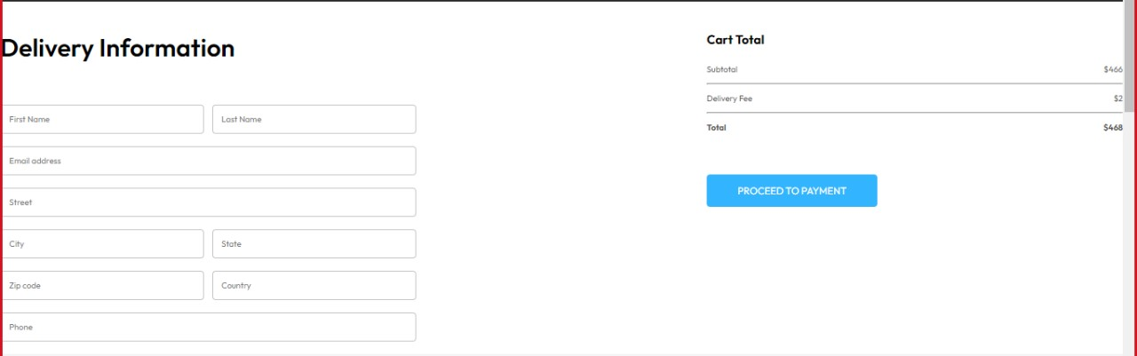

Find Alternative medicine page
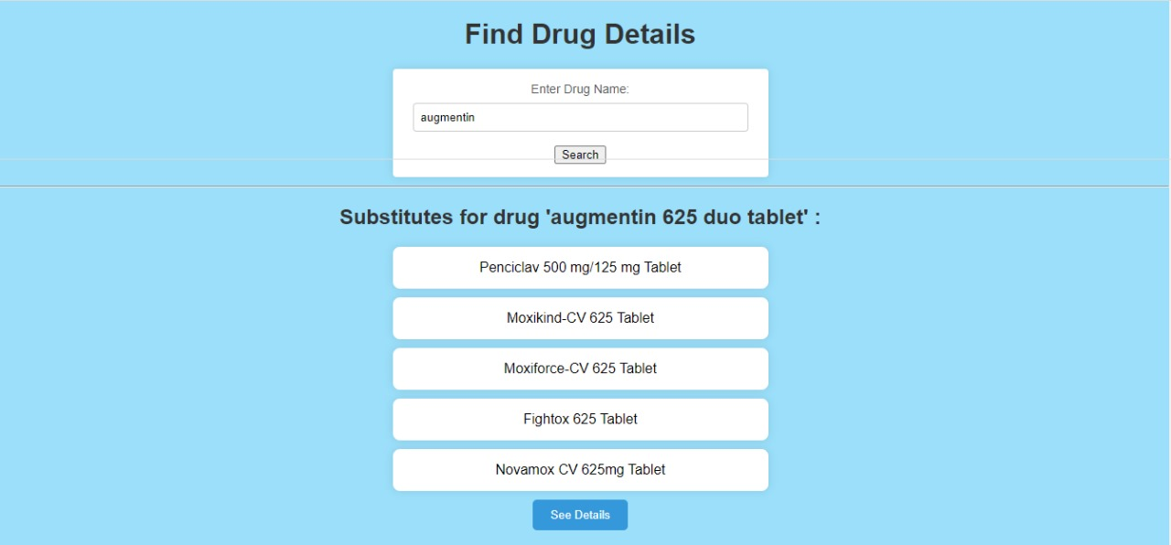
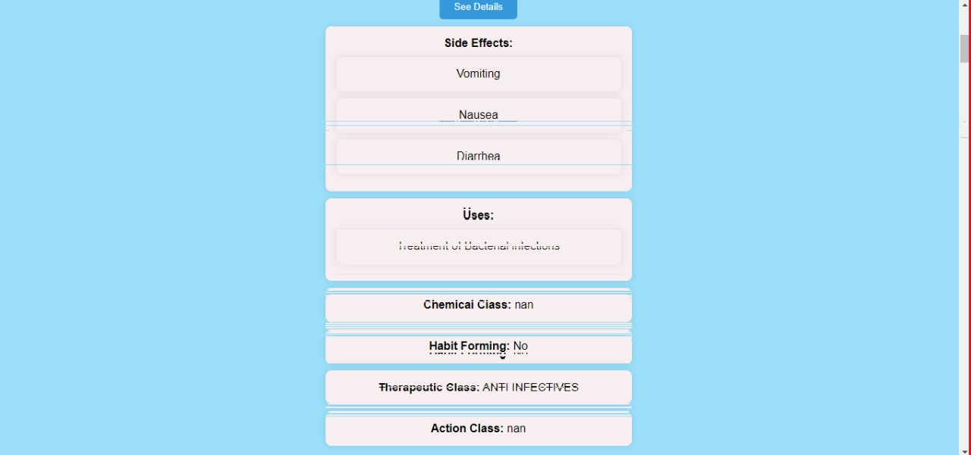

3.8. Software COTS

GoodRx: Primarily U.S.-focused, it helps users find the best prices for medications and offers discounts at pharmacies.
1mg (now Tata 1mg): An Indian healthcare platform that allows users to order medicines, book lab tests, and consult doctors online. It also provides detailed information about drugs, substitutes, and pricing.
Pharmapedia: A free-to-use app that provides comprehensive information about medicines, including dosage, uses, and side effects. It focuses on guiding users with medication knowledge.

Chapter 4

Software Development

Coding Standards

This application is designed with a clean, modular structure, adhering to best practices to ensure scalability, maintainability, and efficient functionality. The app employes the MongoDB for the database, Express.js for backend logic, React for the frontend interface, and Node.js for the runtime environment. Key highlights of the development process include:
- Frontend Development (React):
  - Built using functional components with React Hooks (useState, useEffect, useContext) for state and lifecycle management.
  - Component reusability is emphasized, with clear separation of concerns across reusable and page-level components.
  - CSS Modules and scoped styling are used to maintain clean and conflict-free designs.
  - API interactions are managed centrally in a services/ directory using libraries like Axios, ensuring a clean separation of data fetching logic from UI components.
- Backend Development (Node.js and Express):
  - The backend is structured using the MVC (Model-View-Controller) pattern, separating routes, controllers, and database interactions for better maintainability.
  - MongoDB is integrated with Mongoose, leveraging schemas for consistent data validation and interaction.
  - APIs are designed using RESTful principles, returning meaningful HTTP status codes and structured responses.
- Authentication:
  - Authentication is implemented using JSON Web Tokens (JWT), with secure token storage in HTTP-only cookies or secure local storage.
  - Backend authentication flows ensure secure user login, registration, and token validation with middleware to protect private routes.
  - React Router guards redirect users based on authentication status, enhancing navigation and user experience.

Development Environment

This project is built using a combination of modern tools and technologies to create a seamless platform for medicines. Here's how the development environment is structured:
1. Backend Development:
The backend is powered by Node.js, which handles all the server-side operations, such as managing user authentication, processing requests, and connecting with the database.
Flask API is integrated specifically to handle tasks like finding cheap medicine alternatives, leveraging its ability to work efficiently with Python.
- Medicine Alternatives:
A Python is used for analyzing a medicines dataset to find affordable substitutes. This Python-based functionality communicates with the backend through the Flask framework.
- Payment Processing:
Payments are processed using the Stripe API, ensuring secure and reliable transactions during the checkout process. Stripe handles various payment methods, providing flexibility to users.
- Frontend Development:
The user interface is designed using React, ensuring a smooth and interactive user experience. React makes it easy to create dynamic pages, such as login forms, shopping carts, and order tracking.
- Database Management:
The project uses MongoDB to store and manage data, including user information, prescriptions, order details, and medicine records. MongoDB's flexibility in handling unstructured data is ideal for this application.
6. Diagrams and Documentation:
All the UML diagrams, including sequence, activity, and state transition diagrams, are created using Visual Paradigm. This ensures clear communication of system design and workflows.

4.3. Software Description

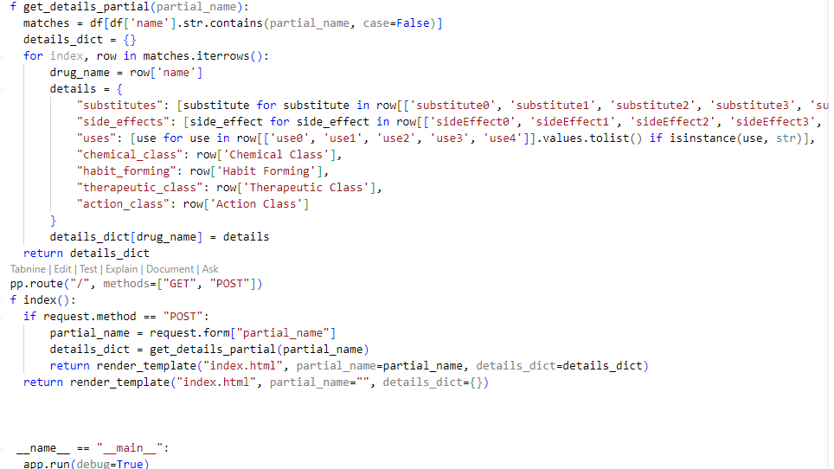
This Python-based web application is designed to facilitate the retrieval of detailed drug information using partial search queries. Built using the Flask web framework, it dynamically processes user inputs and provides relevant drug details, including substitutes, side effects, uses, and classification information. Below is an overview of the application's functionality:
Core Functionalities
- Search for Drug Details:
  - Users can input a partial name of a drug.
  - The application retrieves and displays matching drugs from a dataset, showcasing details about substitutes, side effects, uses, and classification categories.
- Drug Details Extraction:
  - The get_details_partial function:
    - Filters the dataset (df) for drugs with names matching the input query, case-insensitively.
    - Constructs a dictionary containing detailed information for each matching drug.
    - Extracted details include:
      - Substitutes: Alternate drugs (up to 5 substitutes).
      - Side Effects: Common side effects (up to 5 side effects).
      - Uses: Therapeutic uses (up to 5 uses).
      - Classification:
        - Chemical Class: The chemical category the drug belongs to.
        - Habit Forming: Indicates if the drug is habit-forming.
        - Therapeutic Class: The therapeutic domain of the drug.
        - Action Class: Mechanism of action or pharmacological class.
- Dynamic Web Interface:
  - The Flask index route handles both GET and POST requests:
    - GET Requests: Display an initial empty search form.
    - POST Requests: Process the search query and return results for the provided partial drug name.
  - The results are rendered dynamically in the index.html template.
- Scalable Template Design:
  - The index.html template supports displaying:
    - Search results with detailed drug information.
    - Informative error handling if no matches are found.

